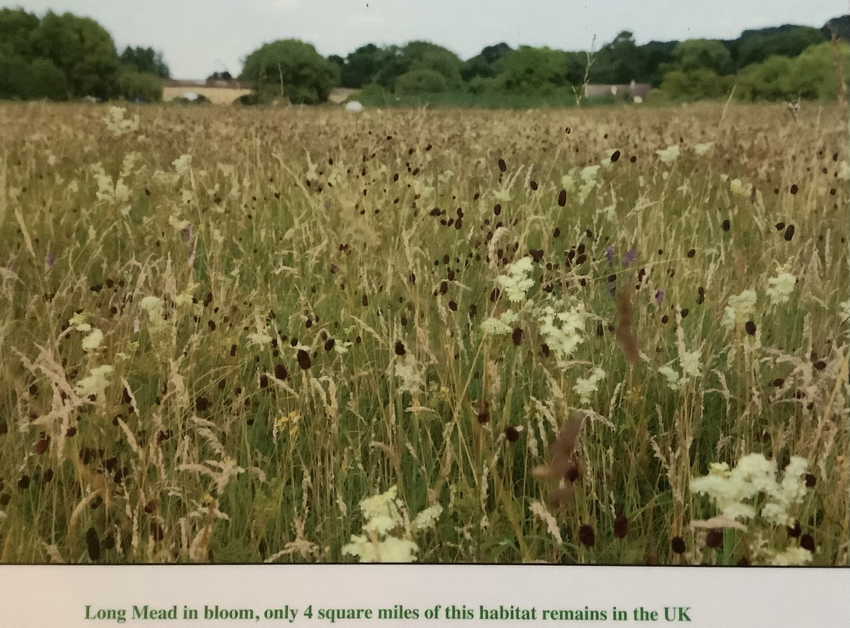
Long Mead Meadow
A century ago you could have walked from Lechlade to Oxford through hay meadows teeming with insects feeding on plants with common names like sneezewort, pepper saxifrage, doddery dicks, crested dog’s tail, lady’s bedstraw, eggs and bacon, jack-go-to-bed-by-noon, and devils-bit scabious, but now Long Mead is one of the few sites where you can enjoy a close encounter with one of the most botanically biodiverse habitats in the UK.
Like Long Mead, many of these meadows are over 1000 years old and they still provide their original function in 21st century agriculture. Indeed, it would be difficult to find a habitat that ticks more boxes on the list of ‘ecosystem services’ - food, flood mitigation, carbon capture, water filtration, and delight - than these ancient floodplain meadows,
This habitat is now so rare that if it were an animal, it would be on the red-ist of red lists and there would be coachloads of tourists lining up to admire and photograph one of the last ones in the wild. Their continuing loss, however, will appear on no ledger and ‘shifting baseline syndrome’ will ensure that in a few generations the tragedy of the loss will be forgotten. Locally, Eynsham's Thames valley Wildflower Meadow Restoration Project has been created specifically to ensure that this does not happen, by recreating wildflower meadows and create ‘bigger, better, more joined up’ landscape of these jewels of our heritage.
Long Mead Meadow is now under threat from Botley West.
The latest version of maps released by the Developer, reveal plans to dig a trench through Long Mead meadow to enable their cables to cross the Thames near Eynsham. Long Mead is part of only 4 square miles of original floodplain hay meadow left in the UK and must be protected. It featured in a film produced for Cop26 and it would be a huge embarrassment for the government if this important floodplain was destroyed on their watch.
Please write to your Parish/District councillors and the Planning Inspectorate, details of how to do this can be found on the Stop Botley West website: https://stopbotleywest.com

