**Agenda**

* + 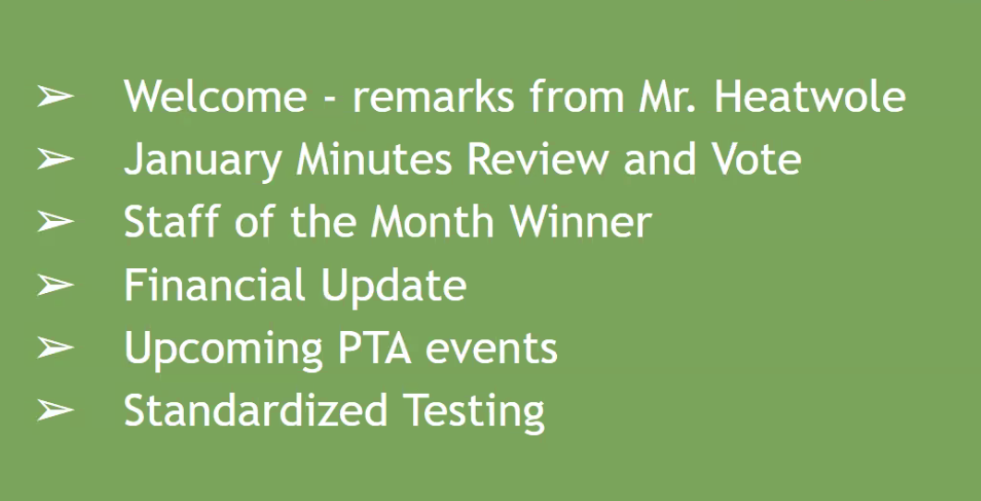

**Principal Heatwole Update**

* Members of community are very uneasy for good reason
* It’s an unsettling time, but FS remains a source of solace
  + Kids are happy, staff is happy
* Dr. Thomas, Superintendent of MCPS, provides information around these topics in “Thursday Things to Know”
* “How we treat kids is not policial, it's ethical. As the political tides change, our commitment to children doesn’t change. How we treat children does not and will not change”
* Plyer v. Doe 1982: Upheld rights of undocumented students to a public education

**Q&A**

* **What happens if ICE comes to the school?**
  + Sensitive areas doctrine ICE followed previously has been overturned
  + FS has strict policies if ICE comes to the school - agents must wait outside while General Council is contacted
  + ICE would require a Search Warrant and/or Subpoenas to be allowed on premises
* **What can we do to support members of our community who are under threat?**
  + No easy answers to this right now, but will be something we’ll need to continue to focus on in the coming days, weeks, and months
  + We’ll be navigating this together
* **Are there negative federal financial implications for continuing equity activities?**
  + Not officially
  + Federal budget is up in March, likely to be more discussion around this at a national level
  + We get alot of federal funding at the local level so we’ll have to see how that pans out
* **If Department of Education is eliminated, do we need to worry about our children's IEP accommodations?**
  + No, IEP support comes from the Individuals with Education Disabilities Act (IDEA) which is a federal law
* **January Minutes** → Approved
  + 23 votes in room/ 10 online
* **Teacher of the Month**

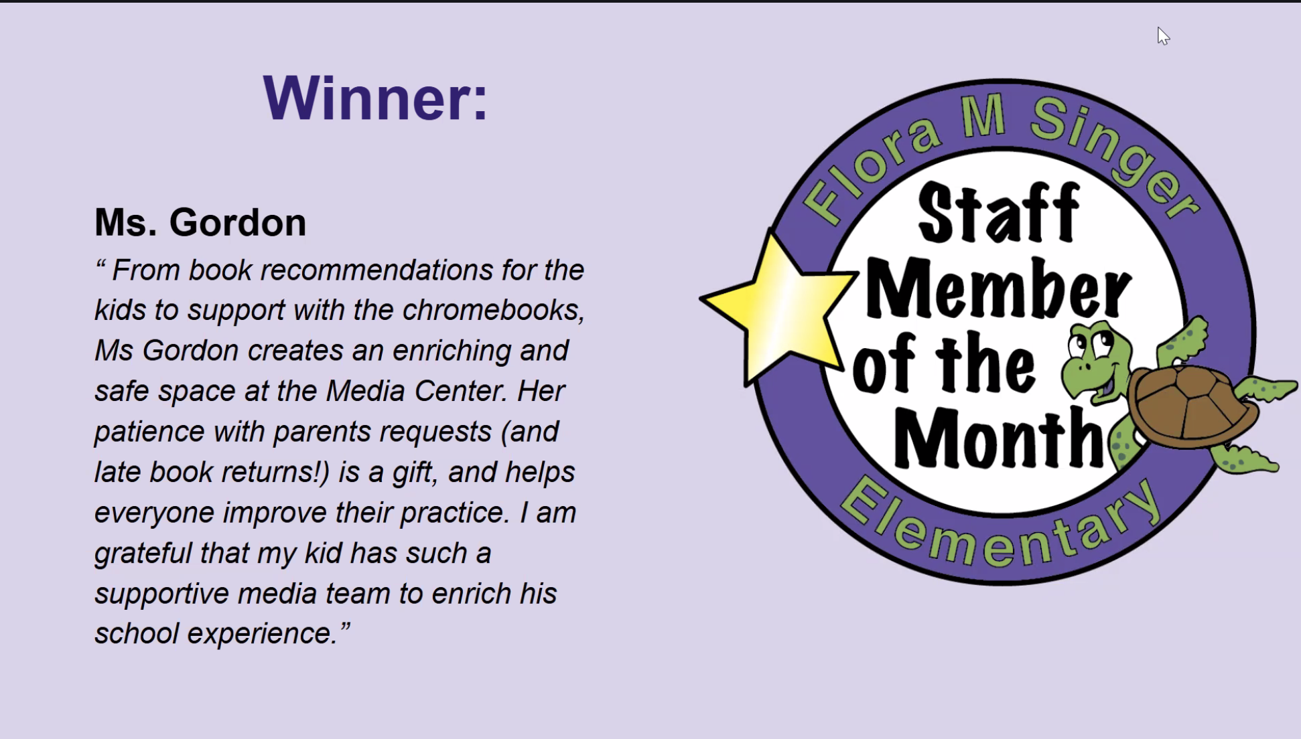

* **Budget Highlights**
  + $1400 from Dine Outs so far
  + Go to [SingerPTA.net/documents](http://singerpta.net/documents) for full report
* **PTA Events** 
  + **Dine Outs**
    - Pacci’s 2/11
    - Nandos 3/18 - donate 40% sales from downtown Silver Spring location
  + **Valentines Parties 2/14**
    - Parents are invited
    - Lists of students are being distributed
  + **Teacher Appreciation**
    - La Finca Coffee
  + **International Night** 
    - Feb. 22, 2025 6pm
    - 38 tables - largest to date
    - Volunteers needed
  + **Student Directory**
    - Almost ready and will be available electronically
    - Paper copies can be requested
  + **Auction Updates**
    - Silent Auction opens 3/1, Event at Solaire Social 3/7
      * Can preview items, new items added daily
    - Event tickets available now QR Code **→**
    - Have a donation?
      * Email [singerauction@gmail.com](mailto:singerauction@gmail.com)
  + **STEM Fair**
    - March 29th 10am-12pm
    - Judging will be more organized this year
    - PTA will provide boards for participants
* **BINGO Night**
  + Save the Date 4/25 6:30-8pm
  + Great entry point for people wanting get involved
* **Earth Day**
  + April 5th 9:30-11:30a Community Clean Up
  + Gratitude Station where kids can write thank you cards for FS Sustainability Committee and Recycling Staff
* **Standardized Testing**

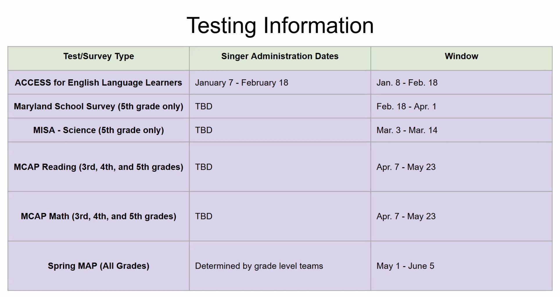

**Attendance**

**In-Person**

1. Rachel Gellman
2. Beth Angerman
3. Hillary Rothberg Geldner
4. [Chris Reynolds](mailto:urban.economist@gmail.com)
5. Kenli Kim
6. Elizabeth Baden
7. Jenny Ochoa
8. Susan Massey
9. [Laura Donnelly Smith](mailto:ldonnellysmith@yahoo.com)
10. Elizabeth O’Bryan
11. Kim Kincaid
12. Anke Mann
13. Kate Kaulock
14. Rachel Shuman
15. Nancy Khau
16. Jared Marcotte
17. Sarah Barthel
18. Joanna Grossman
19. [Shira Printup](mailto:shira.fishman1@gmail.com)
20. Juana Gaviria
21. Matt Llyod

**Zoom**

1. Jocelyn Donnelly
2. Amy Sussman
3. Jennifer Cannons
4. Ian Reynolds
5. Patsy lloyd
6. Lauren Robertson
7. Erin Gajarsa
8. Christie Weaver
9. Jessica Alvarez
10. Russell Provost
11. Ann Veihmeyer
12. Zoë Randol
13. Matildah Mautlane
14. Aubrey Ganon
15. Bridget Quinn
16. Kim Fisher
17. Renee Levent
18. Elyssa Monzack
19. Jen Floran
20. Crys Hernandez
21. Amit Nakra
22. Naomi Mulligan Kolb
23. Christine Bacsa
24. Christine Riley