- Welcome
  - PTA President: R. Gellman
- Vote to approve minutes
  - 19 votes to approve
- Staff member of the month
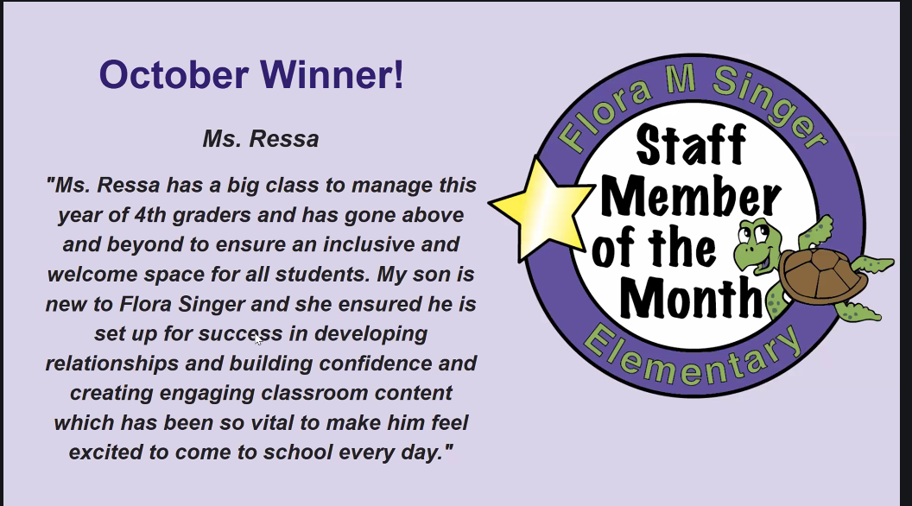
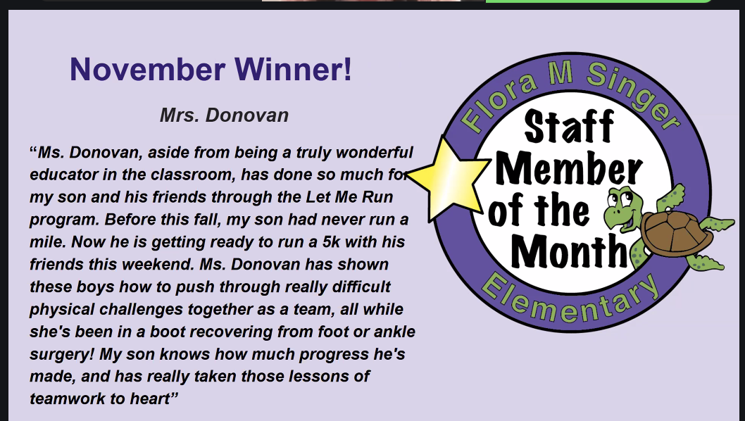
- Budget Update
  - Revenue Highlights
    - Bookfair was super successful $3700 for PTA, $3700 credit to school
    - Membership drive $7,000, all time high membership!
  - Expenses Highlights
    - Grants for equity books
    - Assemblies
- Bookfair
  - Hugely successful, broke a Singer record!
  - THANK YOU the >60 volunteers who made this possible
- PTA Singer Needs
  - Hosted XMinds nonprofit collaboration of parents, educators, and service providers to enhance the educational experience for students with autism
  - Upcoming sessions for Spanish & Amharic speaking parents

- Winter After School Activities
  - Jan 20-Apr 11
  - 14 vendors offering 19 classes e.g. cooking, pottery, robotics, karate
  - Registration via Kiddo
    - See PTA Website or take-home flyer
  - Scholarships available

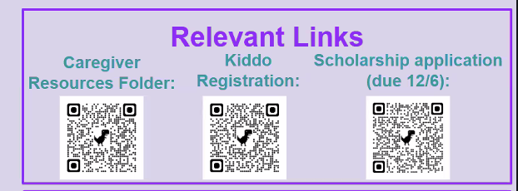
- Restaurant DineOuts
  - East Hollywood Cafes 12/6-12/8
  - Parkway Deli in January, Date TBD
- Parent Night Out
  - Dec 13 6:30-9:30pm, Third Hill Brewing Company
  - Musical entertainment by Booze Island
  - Coincides with KAH Kids Night Out
    - Recommend early registration with KAH as availability may be limited
- Holiday Giving
  - Anticipate about 80 children will be supported
  - Target Gift Cards or specific items
- Auction 101
  - Virtual Auction with in-person event March 7th
  - New location! Solaire Social, Silver Spring
  - Want to help?
    - Donations
    - Share action link
    - Bid in the auction
    - Support room parent with basket donations
  - Contact: singerauction@gmail.com
- Next Meeting: Jan 7th
  - Sports panel
- Principal Updates
  - Thank you to everyone who supported the Book Fair & Fall Festival
  - Flora Singer Day was also hugely successful
    - Focused on ethos of Flora Singer: collaboration, cooperation, togetherness
  - AHA Fundraiser
    - Over $5,000 raised to date
  - Upcoming Events
    - Winter Choral Concert next Thursday
    - Culture Arts Assembly
    - Sligo Band & Orchestra to play for FS 3rd-5th graders

Virtual Attendance
- Chris Reynolds
- Katie Donovan
- Sarah
- Morgan Hoople
- Christine Iannicelli-Rippen
- Ryan and Alexandra Connor
- Sarah Barthel
- Elizabeth Baden
- Hillary Rothberg (Geldner)
- Shira Fishman Printup
- Catherine Foxman
- Aaron Foxman
- Amanda Lorch
- Susan Massey
- Elyssa Monzack
- Celia Taylor
- Stephanie Hsu
- Tamara Forys
- Julie Francis
- Naomi Mulligan Kolb
- Bridget Quinn
- Kenli & Gene Kim
- Patsy and Matt Lloyd
- Kirk knobelspiesse
- Barbara balestra
- Kelly Riley
- Lauren Whitney
- Tara Marini
- Jocelyn Donnelly
- Margaret Norris
- Rachel Gellman
- Christine Riley
- Kyle Heatwole

