Flora Singer PTA Meeting
Virtual: Zoom
May 27, 2025
Meeting Minutes

Agenda
- Update & End of the Year Activities
- Staff of Month Winner
- April Minutes & Passage Vote
- Budget Review & Membership Vote
- Bylaws Votes
- Membership Survey Overview
- 2025-2026 Board Vote
- Principal's Updates

- President’s Update: End of the Year Activities
  - Final Dine out: Tropical Smoothie Cafe 6/11 5pm
  - End of Year Picnic 6/13 at 6pm: Food Trucks, Outside games, Bring a blanket
  - Walk, Bike, or Roll 6/4 - more details to come
  - Rockin’ Recess: 6/4 at lunch
  - 5th Grade Activities
    - Dance 6/5
    - Field Trip 6/5
    - Promotion Ceremony 6/12
- Staff of Month Winner
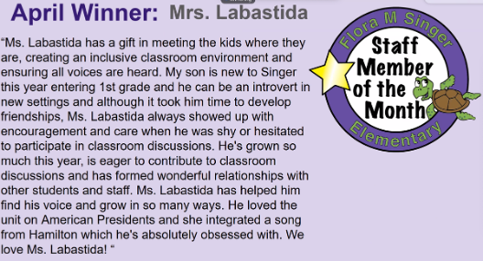
- April Minutes & Passage Vote
  - Passed, all in favor
- Budget Review & Membership Vote
  - Budget Voting: Passed (20 in room, 10 online)
- Bylaws Votes
  - Bylaw Voting: Passed (20 in room, 10 online)

- Membership Survey Overview
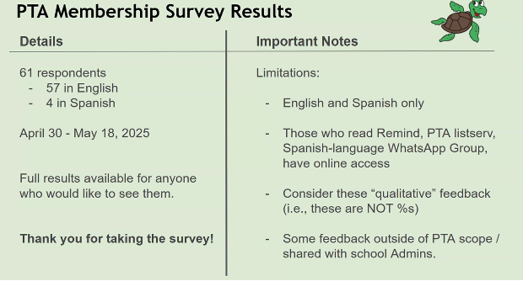
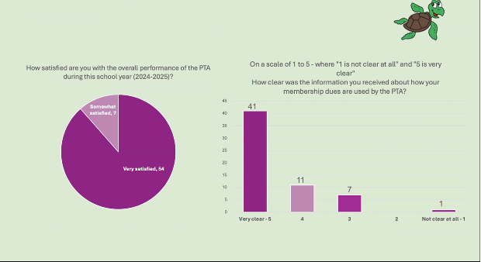
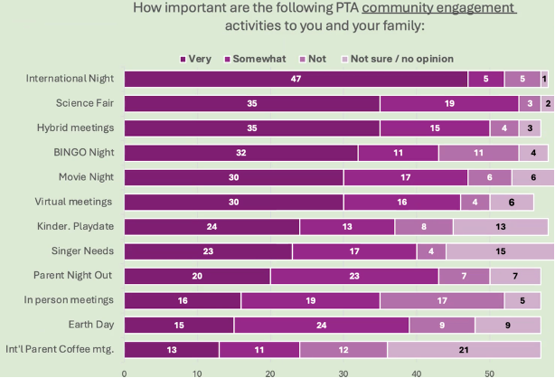
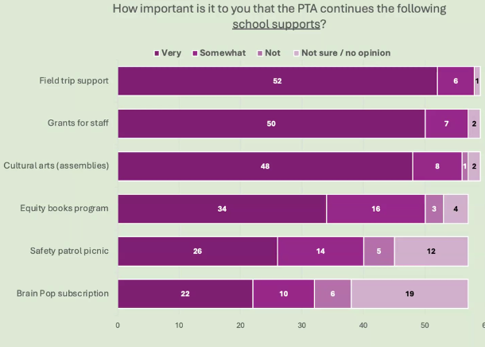
- 2025-2026 Board Vote
  - Core Board Positions
    - Corresponding: Elected, None opposed, 9 votes online
    - Recording: Elected, None opposed in room, 9 votes online
    - Needed for PTA to continue!
    - Need Vice President (formally President Elect)
    - Treasurer Elect
    - 2-year positions – first year shadow in preparation for serving the following year
    - Need a VP of Fundraising! Are you interested – email president@singerPTA.org
- Thank you for your service!
  - Volunteers of the Year
  - Thank you Dr. Grossman
  - Thank you Rachel Gellman (outgoing PTA President)
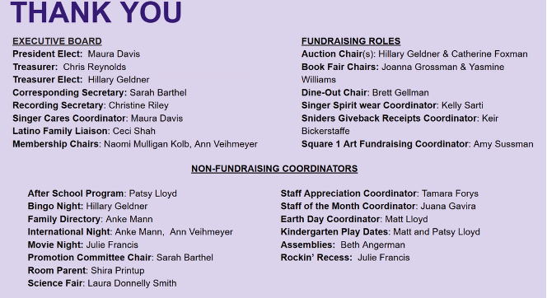
- Principal’s Update: Mr. Heatwole
  - Articulation Input: see newsletter for input form
  - This informs classroom assignments and is also shared with the teachers next year
    - Updates for next year: 1.4 arts (went down), ELD unchanged, HSM increased support
  - Transition Day: Monday 8/25: Details forthcoming but may or may not be combined with Open House

Attendance Sheet (virtual & In-person)
- Rachel Gellman
- Kirk Knobelspiesse
- Catherine Foxman
- Lauren Whitney
- Tara Marini
- Adejumoke Ojo
- Aaron Foxman
- Bridget Quinn
- Margaret Norris
- Britt Gordon-McKeon
- Elyssa Monzack
- Aubrey Ganon
- Helen Chabot
- Christine Riley
- Tamarea Forys
- Elizabeth Baden
- Amy Sussman
- Shana Grossman
- Cecilia Mundaca Shah
- Rosa Marroqin
- Yesy Portillo
- Yakelin Oquino
- Jenny Ochoa
- Susan Massey
- Eric Gumah
- Chris Reyonlds
- Beth Angerman Black
- Maura Davis
- Naomi K. Mulligan Kolb
- Shira Printup
- Laura Donnelly Smith
- Nancy Khun
- Joanna Grossman
- Juana Gauiria
- Elisabeth O’Bryan

