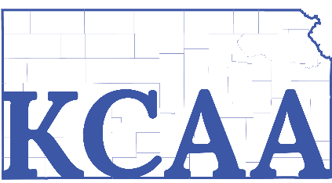

**KANSAS COUNTY ADMINISTRATORS’ ASSOCIATION**

**ANNUAL MEETING**

Wednesday, October 19, 2022, 9:30 a.m.

Redbud Room, Sheraton Overland Park

1. Introductions – All
2. Review of Financial Report – April Warden, Secretary/Treasurer

* Setting of 2023 dues amount

1. National Association of County Administrators Report
2. Legislative Report – Lucas Goff
3. Election of Officers for 2023 -2024 – Maury Thompson/President
4. President – Current – Maury Thompson
5. President-Elect – Current – Lucas Goff
6. Secretary/Treasurer – Current – April Warden

* **ARTICLE VI – Board of Directors**

1. Roundtable Discussion of Current Issues