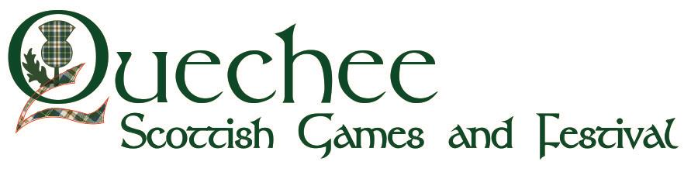

Clans and Societies Registration Form 2024

Scottish Arts’ Quechee Games, 45 Deweys Mills Rd, Hartford, Vermont 05047

~ staying true to and proudly carrying on
the traditional spirit of the Highland Games ~

Tent space is free again this year!

Includes 2 FREE Games tickets, 1 FREE parking pass, 1 FREE tent space, and 1 FREE website listing (including link to website or social media platform)

Clan/Society Name: ________________________________________________

Representative: ___________________________________________________

Email: __________________________________________________

Cell: ____________________________________________________

Clans Only - Official Name of Clan for Calling of the Clans (please include any notes on pronunciation):

________________________________________________________________

Are you interested in having an advert in our Games Program?
(prices TBC: Business-card size $40, quarter page $75, half page $150, full page $200, full page front inside, back, back inside color $250) _______

Would your clan/society like to sponsor a trophy ($50) _______or medals set ($30) _______or present a Clan/Society Award or Scholarship ($____ amount of your choice) to a piper, drummer or Highland dancer?

(Trophy/ medal/award/ scholarships presentation takes place on Main Field)

PLEASE COMPLETE AND RETURN FORM BY 8/1/24 TO: cmacpherson@quecheegames.org
OR MAIL TO: Claire MacPherson, 26 Granli Drive, Andover MA 01810

