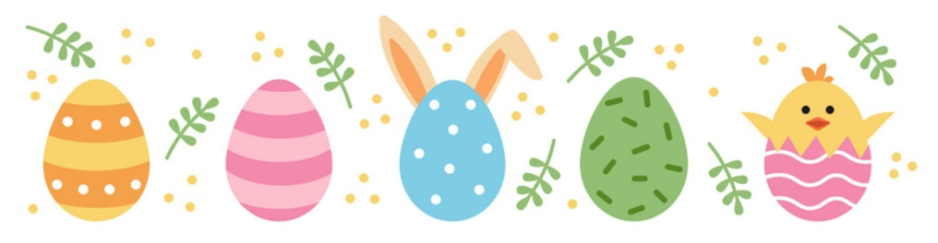
The British Pantry
April 2023 High Tea
Served on an elegant three-tier Tray

First Tier – A selection of Finger Sandwiches (House-made Chicken Salad with Cranberries, Cream Cheese/Cucumber, & British Egg Salad)
& a traditional fresh-baked Sausage Roll in puff pastry

Second Tier – Two fresh-baked Scones (Plain & Lemon Poppyseed)
+ House-made Clotted Cream, & Jam

Third Tier – White Chocolate Raspberry Bar, Iced Tea Cookie, Cheesecake Bite
*Desserts are subject to change*

All served with unlimited pots of PG Tips Tea

$29.99 per person, excluding tax/tip
An 18% Gratuity will be added to tables of 5 or more.

