Rugby Xplorer Registration
How To Set Up A Rugby Xplorer Member Profile
Video tutorial: https://youtu.be/aZjB1uoHm20
- Go to https://myaccount.rugbyxplorer.com.au
- Enter in your personal email (not a role-specific email; RX assigns permissions to individual people, it doesn’t require multiple logins for different organizations)
- You may see “You don't have a Rugby ID,” not to worry as once you enter more details the system will be able to pair you with your imported profile if you are a returning parent.
- Select sign me up, and you will be redirected to enter in your personal details
- MAKE SURE that USAR National is selected and not Rugby Australia
  - If you see “We have found some profiles that might be you!” Please select your profile and click continue.
- You will be redirected to the Rugby Xplorer profile homepage

How To Register on Rugby Xplorer for Season 2022-23
Video tutorial: https://youtu.be/3bzRqKJA0ao
- Login to your Member Profile
- Select Register in the upper left hand corner
- Click on Find A Club
- Select the person you are planning to register (you may have children as linked accounts)
- Enter the Club name, select your club, and select next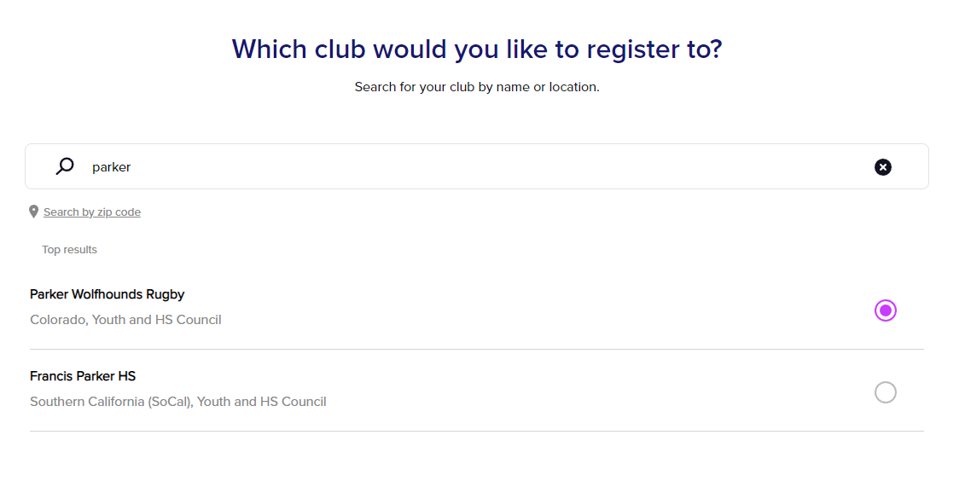

- Choose the registration options applicable to you (you can only register to one role at a time)
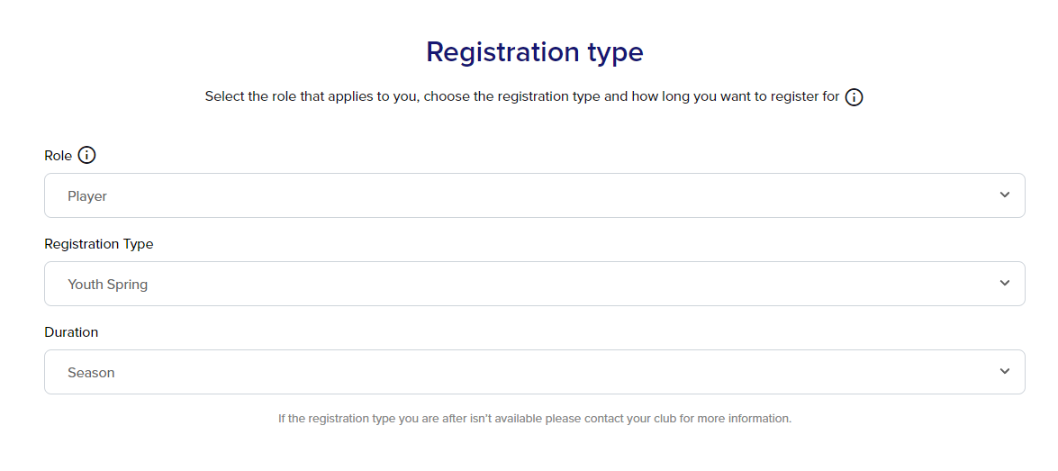
- View the personal information of the person you are registering (you can edit this information later, this step ensures this is the correct person)
- Upload a profile photo (or skip depending on whether this is required by your competition)
- Update your emergency contact information and answer any other questions
[I had to “Manually Enter Address” to get it to work]
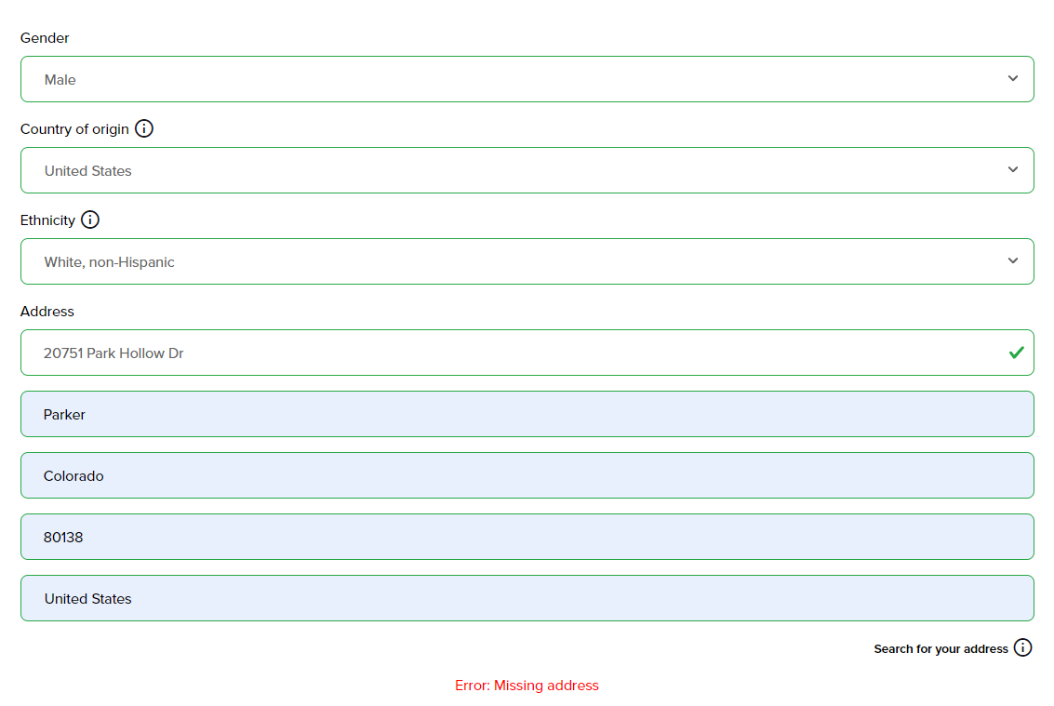

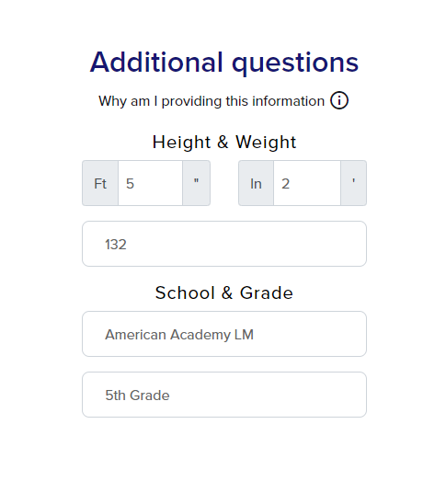
- Review your Registration Summary
- Agree to the Terms and Conditions
- Enter your Payment information to complete your registration
