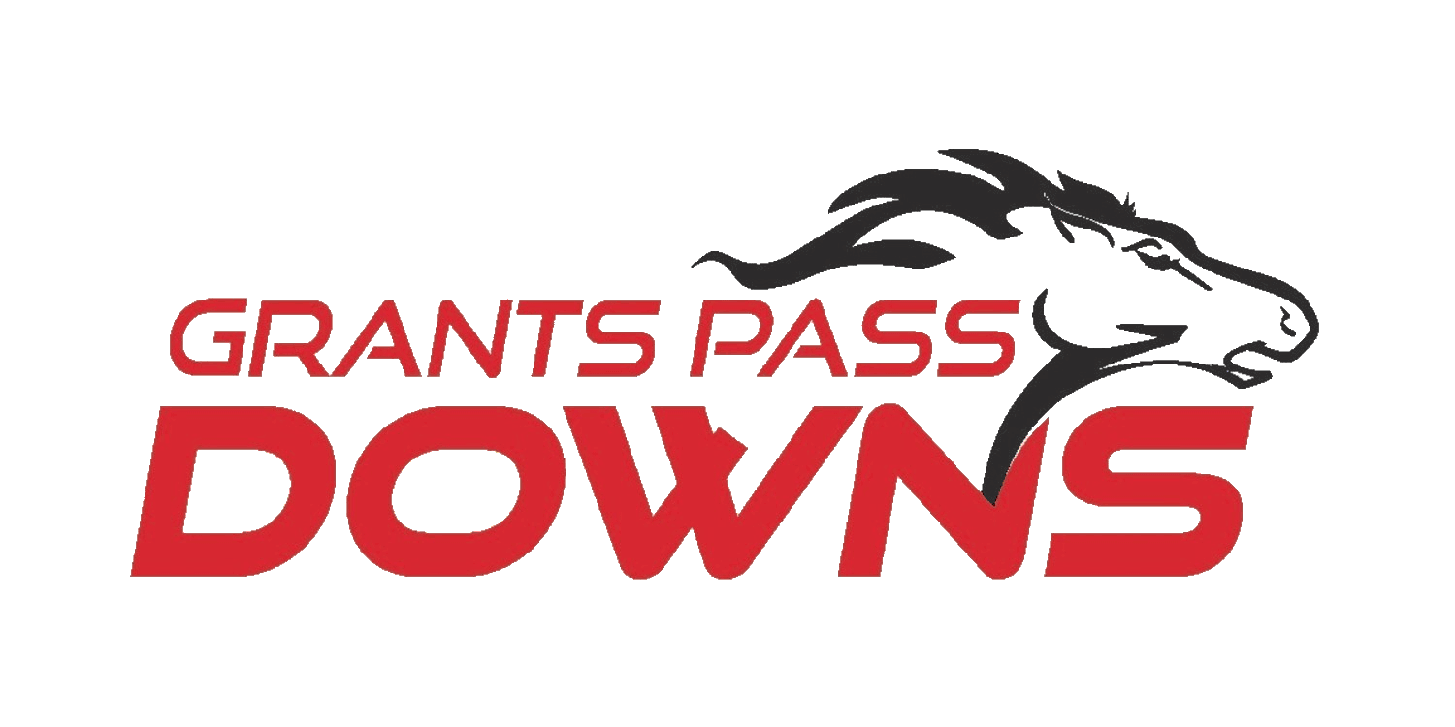
BUNKHOUSE
Bunkspace Living Quarters Rental
Grants Pass Downs 2025

We are pleased to be able to offer beds to the backside of Grants Pass Downs.
Please note that jockeys have first priority to reserve space.

Cost: $5.00/night
Weekend KEY Deposit (refundable): $25
Entire Meet KEY Deposit (refundable): $50

By signing below, you agree to our nightly rate and CLEANING/KEY deposits.
You also agree to leave your area and bunkhouse as you found it upon checking in.
You will be responsible for a Cleaning Fee of $50 if rental is left dirty and/or the key is not returned.

Questions: Call/Txt Twyla 503-317-1413
Mail completed application and fees to SOHRA, PO Box 1694, Grants Pass, OR 97528

NAME (OCCUPENTS):
_______________________________________________ ___________________________________________________
Phone Numbers: _________________________________Phone Numbers: __________________________________
DATES REQUESTED:
_____________________________________________________________________________________________________

SIGNATURE: _____________________________________________________________ DATE______________________

SIGNATURE: _____________________________________________________________ DATE______________________

