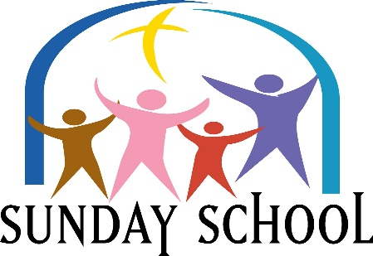
Please Join us Sundays at 9:30 am
This Photo by Unknown Author is licensed under CC BY-NC-ND
Lesson for Sunday, November 6, 2022
“God Picked You”
Ephesians 1: 1-14

Please Join Us Sundays at 9:30 AM
This Photo by Unknown Author is licensed under CC BY-NC-ND
Lesson for Sunday, November 13, 2022
“Christ is Wisdom”
Ephesians 1: 15-23

Please Join Us Sundays at 9:30 AM
This Photo by Unknown Author is licensed under CC BY-NC-ND
Lesson for Sunday, November 29, 2022
“We Are God’s Handiwork”
Ephesians 2:1-10

Please Join Us Sundays at 9:30 AM
This Photo by Unknown Author is licensed under CC BY-NC-ND
Lesson for Sunday, November 27, 2022
“God Gives Tools of Protection”
Ephesians 6: 10 - 18

