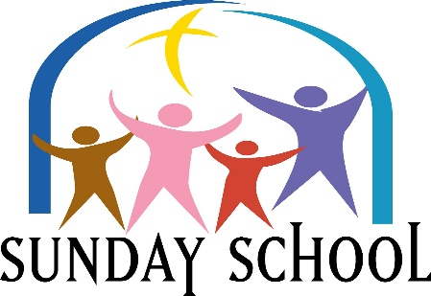
Please Join us Sundays at 9:30 am
This Photo by Unknown Author is licensed under CC BY-NC-ND
Lesson for Sunday, December 5, 2021
“Justice and Obedience”
Deuteronomy 5:1-3, 10:12-13, 27: 1-10

Please Join Us Sundays at 9:30 AM
This Photo by Unknown Author is licensed under CC BY-NC-ND
Lesson for Sunday, December 12, 2021
“Justice and Kindness”
2 Samuel 9:1-7, 9-12

Please Join Us Sundays at 9:30 AM
This Photo by Unknown Author is licensed under CC BY-NC-ND
Lesson for Sunday, December 19, 2021
“Justice and Righteousness”
Isaiah 9:2-7

Please Join Us Sundays at 9:30 AM
This Photo by Unknown Author is licensed under CC BY-NC-ND
Lesson for Sunday, December 26, 2021
“Justice and Deliverance”
Nahum 1:1-3, 6-8,12-13

