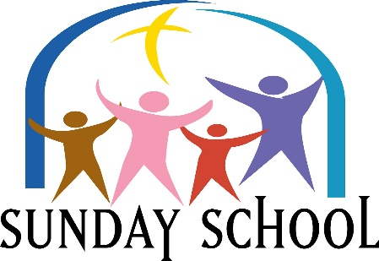
Please Join us Sundays at 9:30 am
This Photo by Unknown Author is licensed under CC BY-NC-ND
Lesson for Sunday, November 7, 2021
“The Rest of the Story”
Revelation 7:9 - 17

Please Join Us Sundays at 9:30 AM
This Photo by Unknown Author is licensed under CC BY-NC-ND
Lesson for Sunday, November 14, 2021
“Who’s in Charge Here”
Revelation 11:15 -19

Please Join Us Sundays at 9:30 AM
This Photo by Unknown Author is licensed under CC BY-NC-ND
Lesson for Sunday, November 21, 2021
“Family Restored”
Revelation 19: 1 - 8

Please Join Us Sundays at 9:30 AM
This Photo by Unknown Author is licensed under CC BY-NC-ND
Lesson for Sunday, November 28, 2021
“No Difference”
Acts 10: 34 - 47

