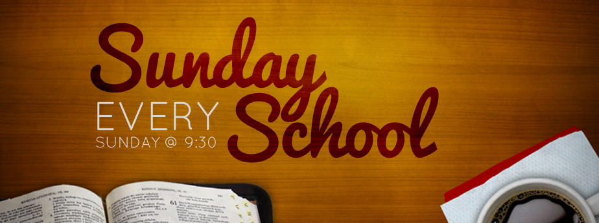

October 3, 2021

Only You

Psalm 100: 1 -5



October 10, 2021

Ball of Confusion

Psalm 9: 1 - 12



October 17, 2021

I Shall Be Released

Psalm 107: 1 – 9, 39 - 43



October 24, 2021

Our House

Psalm 84: 1 - 12



October 31, 2021

I just Want to Celebrate

Psalm 149: 1 -5; 150: 1 -6