Please Join us Sundays at 9:30 am

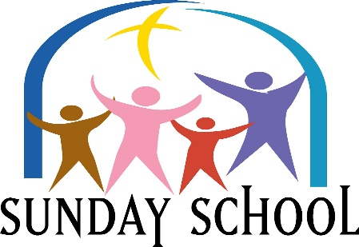

[This Photo](http://akaboogawooga2.blogspot.com/2012/04/our-sunday-best.html) by Unknown Author is licensed under [CC BY-NC-ND](https://creativecommons.org/licenses/by-nc-nd/3.0/)

Lesson for Sunday, August 7, 2022

“No More Tears”

Revelation 21:1-9

Please Join Us Sundays at 9:30 AM



[This Photo](http://akaboogawooga2.blogspot.com/2012/04/our-sunday-best.html) by Unknown Author is licensed under [CC BY-NC-ND](https://creativecommons.org/licenses/by-nc-nd/3.0/)

Lesson for Sunday, August 14, 2022

“No Place Like It”

Revelation 21:10-21

Please Join Us Sundays at 9:30 AM



[This Photo](http://akaboogawooga2.blogspot.com/2012/04/our-sunday-best.html) by Unknown Author is licensed under [CC BY-NC-ND](https://creativecommons.org/licenses/by-nc-nd/3.0/)

Lesson for Sunday, August 21, 2022

“No Better Refreshment”

Revelation 22:1-7

Please Join Us Sundays at 9:30 AM



[This Photo](http://akaboogawooga2.blogspot.com/2012/04/our-sunday-best.html) by Unknown Author is licensed under [CC BY-NC-ND](https://creativecommons.org/licenses/by-nc-nd/3.0/)

Lesson for Sunday, August 28, 2022

“No Substitute”

Revelation 22: 8-21