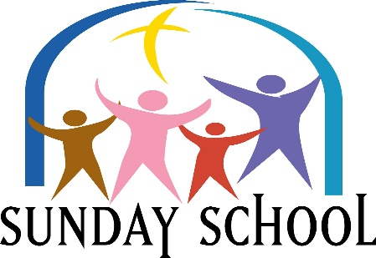
Please Join us Sundays at 9:30 am
This Photo by Unknown Author is licensed under CC BY-NC-ND
Lesson for Sunday, March 6, 2022
“Freedom From Captivity”
Ezra 1; 2: 64-70

Please Join Us Sundays at 9:30 AM
This Photo by Unknown Author is licensed under CC BY-NC-ND
Lesson for Sunday, March 13, 2022
“Free To Worship”
Ezra 5: 6:1-12; 10: 1-5

Please Join Us Sundays at 9:30 AM
This Photo by Unknown Author is licensed under CC BY-NC-ND
Lesson for Sunday, March 20, 2022
“Free To Celebrate”
Ezra 6:13-22,: Leviticus 23: 4-8

Please Join Us Sundays at 9:30 AM
This Photo by Unknown Author is licensed under CC BY-NC-ND
Lesson for Sunday, March 27, 2022
“Free Because of The Lord”
Deuteronomy 8

