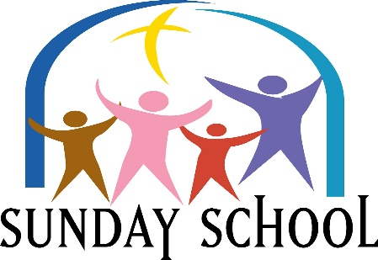
Please Join us Sundays at 9:30 am
This Photo by Unknown Author is licensed under CC BY-NC-ND
Lesson for Sunday, October 2, 2022
“A Protective Family”
Exodus 2: 1-10

Please Join Us Sundays at 9:30 AM
This Photo by Unknown Author is licensed under CC BY-NC-ND
Lesson for Sunday, October 9, 2022
“Expressing Thankfulness”
Deuteronomy 32:3-6; 10-14, 18

Please Join Us Sundays at 9:30 AM
This Photo by Unknown Author is licensed under CC BY-NC-ND
Lesson for Sunday, October 16, 2022
“Confidence Provides Necessary Courage”
Judges 6:1-2, 7 - 16

Please Join Us Sundays at 9:30 AM
This Photo by Unknown Author is licensed under CC BY-NC-ND
Lesson for Sunday, October 23, 2022
“We Want a Human King”
1 Samuel 8: 4-7; 10: 17-24

This Photo by Unknown Author is licensed under CC BY-NC-ND

Please Join Us Sundays at 9:30 AM
Lesson for Sunday, October 30, 2022
“The Heart of a Leader”
1 Samuel 16: 1-13

