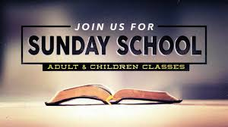
February 6, 2022
9:30 AM
TOPIC: “Speaking Truth to Power”
Scripture: 2 Samuel 12: 1-9, 13-15

February 13,2022 9:30 AM
TOPIC: Restoring Law and Order
Scripture: Ezra 7: 1-10, 23-26

February 20, 2022
9:30 AM
TOPIC: Enduring False Charges
Scripture: Job 8:1-10, 20-22

February 27, 2022
9:30 AM
TOPIC: Hope for Justice
Scripture: Job 43: 1-6, 10 - 17

