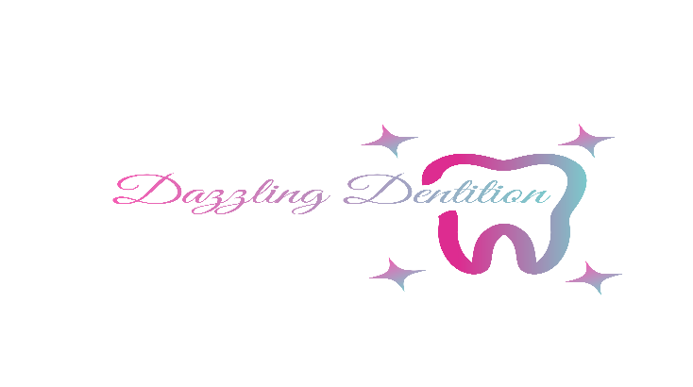

Teeth whitening is designed to lighten the color of your teeth. Significant whitening can be achieved in the vast majority of cases, but **results cannot be guaranteed.** When done properly, the whitening will not harm your teeth or gums. Like any other treatment, it has some inherent risks and limitations.

It is recommended to consult your dentist before using any teeth whitening system.

Temporary tooth sensitivity may occur with this product but should dissipate in a few hours. If product comes in contact with soft tissue (gums lips and skin), white spots may appear. If you have tooth decay, exposed roots, gum disease, braces, have had recent oral surgery or other dental problems consult your dentist before using this product.

This product is not recommended if allergic to carbamide peroxide, hydrogen peroxide or glycerin. **Teeth whitening is intended for natural teeth only.** This product can be used with but will not whiten caps, crowns, veneers, fillings, dentures or any type of dental work.

**Aftercare:**

For a minimum of 24 hrs. after use, avoid consuming coffee, tea, cola or anything that would stain your teeth. If you have tooth sensitivity it will be temporary but use vitamin E oil or a sensitivity toothpaste will bring relief immediately. It is necessary that you brush and floss as directed by your dentist to maintain your results.

Name

DOB

Address

**Please put a check**

1. I agree that I am over the age of 18, am **NOT** under the influence of alcohol or drugs, I am **NOT** pregnant or nursing and desire to receive the teeth whitening procedure. The general nature of the teeth whitening procedure has been explained to me.
2. I have been informed of the nature, risks, and possible complications and consequences of teeth whitening.
3. I understanding procedure may have known or unknown complications including but not limited to: tooth sensitivity, tingling, minor discomfort, and toothache.
4. I understand that results may vary per client.
5. I understand that the teeth whitening procedure is not intended to lighten artificial teeth, composite, crowns, veneers, caps, porcelain or other restorative materials.
6. I understand that if I have multiple fillings. cavities, chips, or cracks in my teeth that the teeth whitening procedure is not best suited for me and I should seek an alternative non-bleaching option.
7. I understand that I may end up with multiple coloring or splotches due to various contributing factors.
8. I am not pregnant or lactating.
9. I understand that this procedure is not permanent, and exposing teeth to various staining

agents will result in changes of shade post bleaching.

1. I elect to receive this procedure from the company in which I am voluntarily seeking services from of my own free will and understand and accept all of the above information

I understand this agreement is binding and that I have read and fully understand all information listed above. I represent that I am over the age of 18 or if under the age of 18, I have a parent and /or guardian signature below and that he/she consents to this procedure under these terms. I have completed this form to the best of my ability and knowledge and agree to inquire about questions I may have before the procedures begins. I have been informed of and understand the contraindications to the requested treatments and agree that I do not have any condition(s) that would make the requested treatment unsuitable. I will inform the practitioner of any discomfort I may experience during the requested treatment to allow them to adjust accordingly. I agree to waive all liabilities toward the practitioner and the company for any injury or damages incurred due to any misrepresentation of my health history.

Signature Date