

**General Information**

Name _____________________________________________________ Birthday ____________

Address _______________________________________________________________________

City ____________________________ State/Province __________ Zip/Postal Code __________

Phone # ________________________ Email__________________________________________

Occupation ____________________________________________________________________

Emergency Contact Name _______________________________ Phone # __________________

Would you like to be added to our email list for specials and discounts? Yes No

How did you hear about us? ______________________________________________________

**Medical/Dental History**

Are you currently taking any medications? Yes No

If yes, please explain: ____________________________________________________________

Do you have any allergies? Yes No

If yes, please explain: ____________________________________________________________

Do you have sensitive teeth? Yes No

I authorize the technician to apply a tooth gem with dental adhesive to the following tooth/teeth (check all that apply):

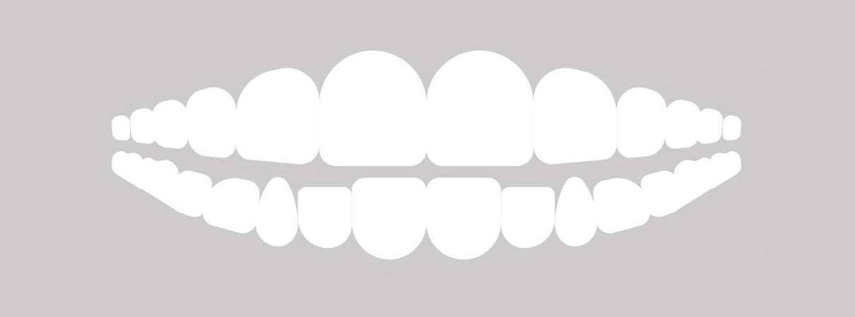

**By signing below, I agree to the following:**

I have completed this form to the best of my ability and knowledge. I agree to inform the technician of any changes in the above information. I agree that I do not have any condition(s) that would make the requested treatment unsuitable. I will inform the technician of any discomfort I may experience at any time during my treatment to allow them to adjust accordingly. I agree to waive all liability toward my technician and the salon for any injury or damages incurred due to any misrepresentation of my health.

Name Printed Signature Date