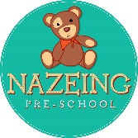

**Nazeing Pre-School, c/o Nazeing Primary School, Hyde Mead, Nazeing. EN9 2HS**

**01992 899028**

**Email -** [nicky@nazeingpreschool.co.uk](mailto:nicky@nazeingpreschool.co.uk)

# Nutrition Policy

**Safeguarding and Welfare Requirement: *Early Years Foundation Stage nutrition guidance Guidance for group and school-based providers and childminders in England May 2025***

Providers must put in place a written procedure for dealing with concerns and complaints from parents and/or carers, and must keen a written record of any complaints, and their outcome. The provider is committed to providing healthy, balanced and nutritious food ensures that all children:   
Get the right amount of nutrients and energy they need while they are growing rapidly, which is especially important for children who might not have access to healthy food at home. This can help prevent children from becoming overweight or obese.  
Develop positive eating habits early on. Children’s early experiences with food can shape future eating habits. This can impact children’s long-term health including maintaining a healthy weight, and good oral health. The early years are a crucial time to reduce health inequalities and set the foundations for a lifetime of good health. Children aged 1 to 5 years have different nutritional requirements to adults. They need to be fed a healthy balanced diet with a range of foods even as they are introduced to solid foods.  
The Eatwell Guide uses government advice to show what a healthy and balanced diet looks like. It shows what a balance of foods should look like in one day or over a whole week.  
The advice in the Eatwell Guide applies to children from the age of 2 years. A healthy, balanced diet is based on the 4 main food groups (fruit and vegetables; potatoes, bread, rice, pasta and other starchy carbohydrates; dairy or dairy alternatives; and beans, pulses, fish, eggs, meat and other proteins). These provide essential nutrients to help children grow and develop. DfE’s help for early years providers’ website has a poster on the 4 food groups. You also need to be aware of allergies. Further guidance on this can be found in the section on ‘Food allergies’. Make sure that food is prepared appropriately to minimise any risk of choking. The Food Standards Agency has 2 posters on how to prepare food safely to avoid choking.

# Policy Statement

Nazeing Pre-School aim to provide a [healthy, balanced](https://www.google.com/search?q=healthy%2C+balanced&sca_esv=50ae17e33ffbd3d5&rlz=1C1CHBF_enGB1112GB1112&ei=Xhu4aIHoGuaGhbIPlpzXMQ&oq=early+years+nutriton+policy+opening+stat&gs_lp=Egxnd3Mtd2l6LXNlcnAiKGVhcmx5IHllYXJzIG51dHJpdG9uIHBvbGljeSBvcGVuaW5nIHN0YXQqAggAMgcQIRigARgKMgcQIRigARgKSIpiULAPWNIwcAJ4AZABAJgB1gGgAbMMqgEFNC44LjG4AQHIAQD4AQGYAg-gAp0NwgIKEAAYsAMY1gQYR8ICBhAAGBYYHsICCxAAGIAEGIYDGIoFwgIIEAAYgAQYogTCAgYQIRgVGArCAgQQIRgKmAMA4gMFEgExIECIBgGQBgiSBwU1LjkuMaAH306yBwUzLjkuMbgHhQ3CBwgwLjMuMTAuMsgHTQ&sclient=gws-wiz-serp&mstk=AUtExfBb69Sprysjy4OhGSM5hJa3a4G-WAl6krfnjERa475QbBcNAkZNROgxOcsfg9gYF32268D4S2LTpZYVoGEqiyScf0KJXbVTIw9AMRVPtgjcLVVxOLJ4bxJjvwM829UfyWM&csui=3&ved=2ahUKEwiay5uLtLyPAxUE-QIHHaPECUEQgK4QegQIARAB) and nutritious diet that supports children's physical and cognitive development, promote a positive relationship with food, and contribute to their overall health and well-being from an early age. Nazeing Pre-School aims to establish good lifelong eating habits, ensuring compliance with statutory frameworks like the [Early Years Foundation Stage (EYFS)](https://www.google.com/search?q=Early+Years+Foundation+Stage+%28EYFS%29&sca_esv=50ae17e33ffbd3d5&rlz=1C1CHBF_enGB1112GB1112&ei=Xhu4aIHoGuaGhbIPlpzXMQ&oq=early+years+nutriton+policy+opening+stat&gs_lp=Egxnd3Mtd2l6LXNlcnAiKGVhcmx5IHllYXJzIG51dHJpdG9uIHBvbGljeSBvcGVuaW5nIHN0YXQqAggAMgcQIRigARgKMgcQIRigARgKSIpiULAPWNIwcAJ4AZABAJgB1gGgAbMMqgEFNC44LjG4AQHIAQD4AQGYAg-gAp0NwgIKEAAYsAMY1gQYR8ICBhAAGBYYHsICCxAAGIAEGIYDGIoFwgIIEAAYgAQYogTCAgYQIRgVGArCAgQQIRgKmAMA4gMFEgExIECIBgGQBgiSBwU1LjkuMaAH306yBwUzLjkuMbgHhQ3CBwgwLjMuMTAuMsgHTQ&sclient=gws-wiz-serp&mstk=AUtExfBb69Sprysjy4OhGSM5hJa3a4G-WAl6krfnjERa475QbBcNAkZNROgxOcsfg9gYF32268D4S2LTpZYVoGEqiyScf0KJXbVTIw9AMRVPtgjcLVVxOLJ4bxJjvwM829UfyWM&csui=3&ved=2ahUKEwiay5uLtLyPAxUE-QIHHaPECUEQgK4QegQIARAC), and work collaboratively with parents and carers to support these goals.

**1. Legislation and Guidance**This policy meets the requirements set out by the EYFS statutory framework (England): requirement that food and drink must be “healthy, balanced and nutritious” and that providers have regard to DfE EYFS Nutrition Guidance (2025). It includes information from: Nutrition & Food Safety (DfE/OHID). The EYFS safeguarding and welfare requirements are given legal force by Regulations1 made under section 39(1)(b) of the Childcare Act 2006.   
This policy ensures all snacks and drinks provided on site are healthy, balanced, and nutritious, and that we support families to provide suitable, healthy packed lunches for their children.

# 2. Roles & Responsibilities

- Manager: Will ensure compliance with this policy and communicate lunchbox guidance to parents via Tapestry.

- Key person’s will verbally share the guidance during the child’s settling in session and adhere to this policy.  
- All staff: follow snack guidance, supervise safe eating, and reinforce consistent healthy messages.  
- Parents/carers: provide a daily packed lunch that meets our healthy lunchbox guidance.

# 3. Snacks (Provided by Setting)

- Offered mid-morning and mid-afternoon.  
- Always include a vegetable or fruit option and a starchy food (e.g., breadsticks, pitta, rice cakes).  
- Dairy or plant alternative offered across the week.  
- No confectionery, or sugary drinks.  
- Served with water or milk only, unless agreed with the Manager.

# 4. Drinks

- Water is available at all times in cups or children may bring in a named water bottle. Staff will ensure the water is kept fresh and topped up throughout the child’s day.  
- Plain milk is provided at snack times.  
- No juice, squash, or flavoured milk permitted, unless agreed with the Mnager.

# 5. Packed Lunches (Brought from Home)

Parents/carers are asked to provide a lunch that reflects our Healthy Lunchbox Guidance. The Health Lunchbox poster will be shared with parents/carers via Tapestry.

Recommended contents include:

- Starchy base: bread, wraps, chapati, pasta, rice, couscous, potatoes  
- Protein: lean meat, fish, eggs, beans, lentils, hummus, tofu  
- Vegetables: salad, raw sticks, cooked veg  
- Fruit: fresh, dried (small amounts), or tinned in juice  
- Dairy/alternative: cheese, yoghurt, fromage frais, fortified plant yoghurt  
- Drink: water or milk only

Foods not permitted in lunch boxes include; sweets, confectionery, sugary drinks/fizzy drinks, whole nuts, and high-risk choking foods not prepared safely. If parents feel their children must have a sweet product this may only be small and a maximum of one item can be included in their lunch box. For example 1 biscuit, 1 small chocolate bar, 1 yoyo bear and not multiple items. If staff feel there are excessive sugary items they will be removed from the lunchbox and returned to you at the end of the day to take home.  
We are a nut and banana free Pre-School. No products containing bananas or nuts are permitted, if a product is found it will be removed and returned to you at the end of the day to take home.

# 6. Allergy & Special Diets

Food allergies can be life threatening conditions for some children and should be taken very seriously. Food allergies develop when the body’s immune system reacts against food proteins which it sees as invaders. It then releases chemicals to attack. Symptoms of an allergic reaction may include: • coughing, wheezing, breathlessness, noisy breathing or a hoarse voice • a red raised rash (hives) • tingly or itchy feeling in the mouth • sneezing or an itchy, runny or blocked nose • stomach pain • feeling sick or vomiting • swelling of face, lips, tongue or eyes • difficulty swallowing • diarrhoea • feeling dizzy or lightheaded • pale or floppy • suddenly sleepy • collapse or unconscious These symptoms can happen on their own or they may be present in a serious reaction.

A severe reaction called anaphylaxis or anaphylactic shock can occur in extreme situations. This is classed as a medical emergency as it can be life threatening and needs urgent treatment. We will administer the child’s auto-injector if they have one and then call 999. We will use the child’s second auto-injector if they have one if they have not improved after 5 minutes. For children who may have anaphylaxis and no previous history we will immediately call 999 detailing their symptoms and the need for urgent assistance. A child who is showing signs of anaphylaxis will remain in the same location. Where necessary, they will be carried to a suitable safe location away from an allergen (for example, if a food item was spilt in their vicinity). Any one or more of the following symptoms may be present: • swelling of throat, tongue or upper airways • difficulty swallowing • wheezing / noisy breathing • breathing difficulty • persistent cough • dizziness • feeling faint • sudden sleepiness • confusion • pale clammy skin • loss of consciousness.

It’s possible to be allergic to anything, but there are 14 common allergens. These are:

• celery • cereals containing gluten (such as wheat, barley and oats and some flours) • crustaceans (such as prawns, crabs and lobsters) • eggs • fish • lupin (such as bread made using lupin seeds) • milk • molluscs (such as mussels and oysters) • mustard • peanuts • sesame • soybeans • sulphur dioxide and sulphites (sometimes found in dried fruits and fruit juices) • tree nuts (such as almonds, hazelnuts, walnuts, brazil nuts, cashews, pecans, pistachios and macadamia nuts). DfE’s help for early years providers website has a full list of common food allergens. It is possible for children with food allergies that are not on this list.

Nazeing Pre-school requests parents/carers share with us if your child has any food allergies before they start at Pre-School. We will complete all necessary care plans for your child. Children can develop allergies at any time, particularly during the introduction of solid foods (weaning). As children may be trying some foods for the first time at Pre-School we will observe and recognise the signs and symptoms of an allergic reaction. If we suspect that a child has a food allergy, we will encourage parents and/or carers to seek advice and diagnosis from a doctor. Nazeing Pre-School will have ongoing discussions with parents and/or carers and, where appropriate, health professionals to develop allergy action plans for managing any known food allergies and intolerances. This information will be kept up to date by providers and shared with all staff. Nazeing Pre-School is a nut and banana free environment. This includes products which contain nuts or banana they are not permitted in the setting. If any of these products are identified they will be removed, your child will not be allowed to consume this at Pre-School and the item will be returned to you at the end of the day. Staff will have discreet discussions to reiterate our policy.  
All dietary needs will be displayed discreetly in our kitchen area where all staff have access to. This list will be looked at before each snack and meal time.

# 7. Mealtime Practice

Mealtimes are a valued part of our day, providing children with opportunities to develop independence, social skills, and healthy attitudes towards food. Children sit together at tables where social conversation is encouraged, helping to build confidence and communication skills. A member of staff is present at each table to model positive mealtime behaviour, providing support where needed, and engage children in meaningful conversations. Children are encouraged to open their food items independently, supporting the development of self-help skills. Any leftovers are placed back into their lunchboxes so parents can monitor food intake.

At snack times, a member of staff records which children have eaten and sits alongside them, promoting an educational dialogue about food, making healthy choices, and fostering a positive and relaxed approach to eating.

We recommend a cool pack in your child’s lunch to keep it fresh, it is essential to do so in the warmer months.

# 8. Celebrations & Birthdays

We mark special occasions with our happy birthday song and hat at circle time. If you wish to bring in something to share with friends we would strongly encourage avoiding sweet items, however if you do provide confectionary your child will share these at the end of the day for children to enjoy at home with parent discretion.

9. **Communication with Families**  
Key information about each child is gathered during home visits or at their settling-in session to ensure individual needs are understood from the outset. We maintain open and ongoing communication with parents and carers, encouraging them to share any updates or changes that may impact their child’s care and learning. The setting uses Tapestry as a tool to share important resources and guidance with families, including the Healthy Lunchbox Guide and food safety information on early years choking hazards. This ensures parents are well-informed and supported in promoting their child’s health, safety, and wellbeing both at home and at Pre-School.  
Any unsuitable lunchbox items that do not adhere to our policy will be discreetly discussed with parents.

# 10. Monitoring & Review

Policy reviewed annually by manager.

# 11. Complaints & Feedback

Concerns about food provision are handled under our Complaints Policy.

# Appendices

Appendix 1 – Healthy Lunchbox Guide  
A parent-friendly guide showing what to include, what to avoid, portion tips, example lunchboxes, and birthday celebration guidance.

Appendix 2 – Early Years Choking Hazards Table (Food Standards Agency, 2024)   
A clear table of common choking hazards and how to prepare foods safely for children under 5. Key points include:   
- Cut grapes, cherries, and cherry tomatoes lengthways and into halves/quarters.  
- Grate or soften hard fruit and veg such as apples or carrots.  
- Remove skins, bones, seeds, and tough rinds where appropriate.  
- Avoid whole nuts and large chunks of cheese or meat.  
- Sausages and hot dogs should be cut lengthways into strips.  
- Children must always sit upright and be supervised while eating.  
(Adapted from Food Standards Agency resource).

Appendix 3 – Allergy & Individual Healthcare Plan template  
Photo, symptoms, dietary management, and emergency response plan.

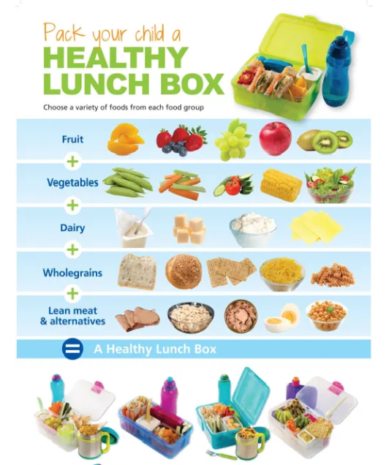

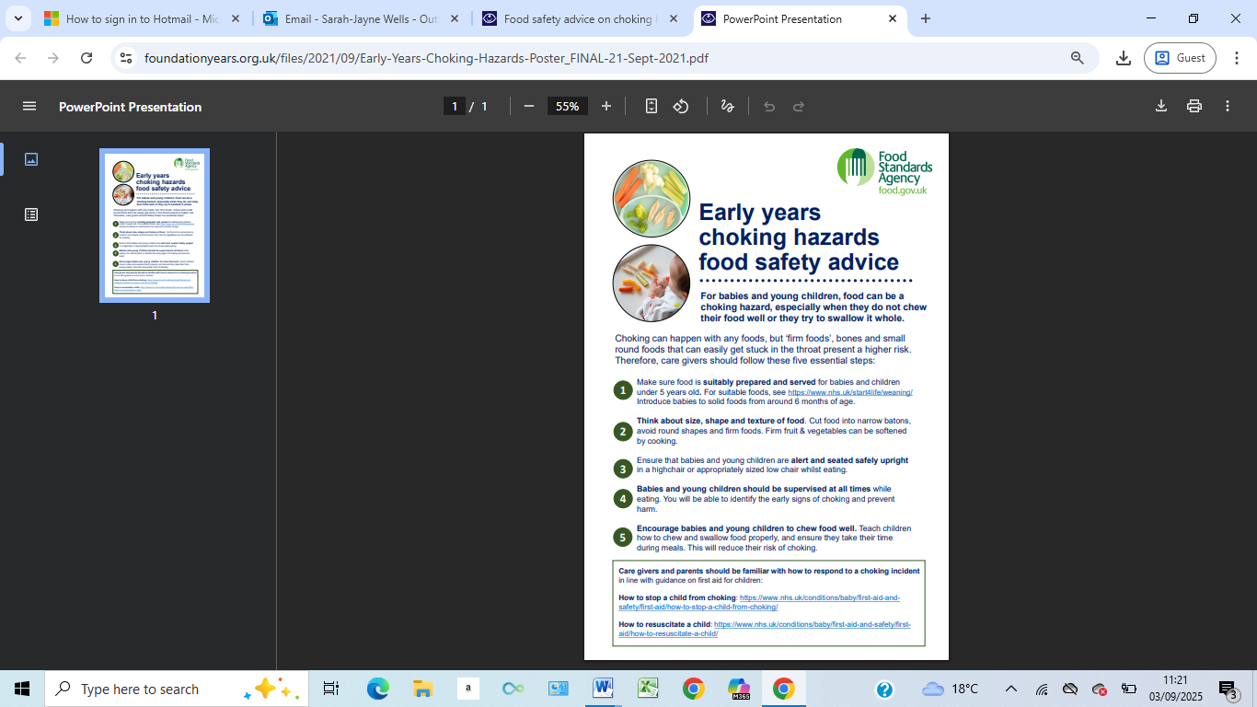

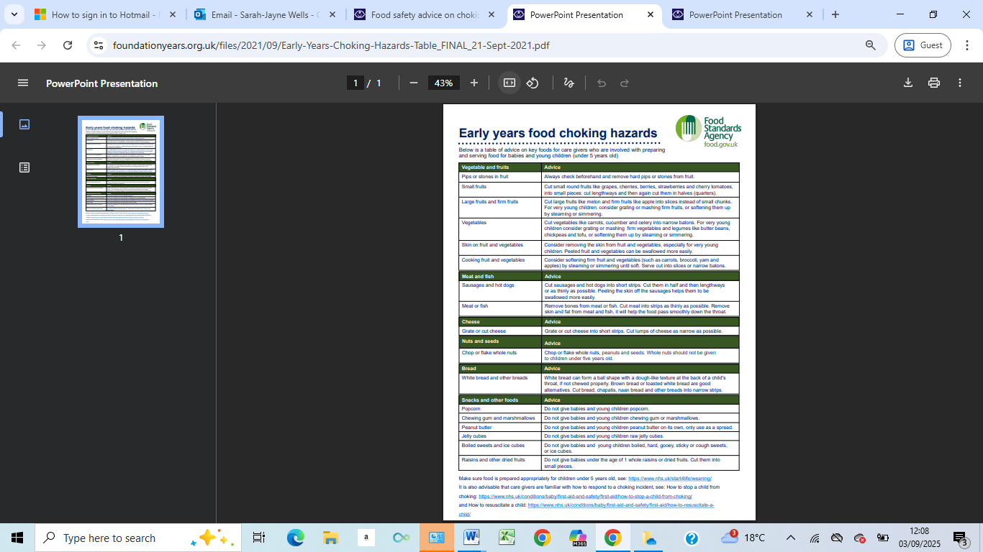

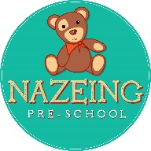

**Nazeing Pre-School, c/o Nazeing Primary School, Hyde Mead, Nazeing. EN9 2HS**

**Individual Health Care Plan**

*This form must be used alongside the individual child’s registration form which contains emergency parental contact and other personal details.*

|  |  |  |  |
| --- | --- | --- | --- |
| Date completed: |  | Review date: |  |

**Child’s details:**

|  |  |  |  |  |  |  |
| --- | --- | --- | --- | --- | --- | --- |
| Full name: | ______________________________ | | | | Date of birth: | ________________________ |
| Address: |  | | | | | |
| Allergies: |  | | | | | |
|  |  | | | | | |
| Medical condition/diagnosis | |  | | | | |
|  | |  | | | | |
|  | |  | | | | |
|  | |  | | | | |
|  | |  | | | | |
| Medical needs and symptoms: | |  | | | | |
|  | |  | | | | |
|  | |  | | | | |
|  | |  | | | | |
|  | |  | | | | |
| Daily care requirements: | |  | | | | |
|  | |  | | | | |
|  | |  | | | | |
|  | |  | | | | |
| Who will be responsible: | |  | | | | |
|  | |  | | | | |
|  | |  | | | | |
| Medication details (Inc. expiry date/disposal) | | | |  | | |
|  | | |  | | | |
|  | | |  | | | |
| Storage of medication: | | |  | | | |
|  | | |  | | | |
| Procedure for administering medication: | | |  | | | |
|  | | |  | | | |
|  | | |  | | | |
| Names of staff trained to carry out health plan procedures and administer medication: | | | | | | |
|  | | | | | | |
|  | | | | | | |
| Other information: | | |  | | | |
|  | | |  | | | |
|  | | |  | | | |
|  | | |  | | | |
| Date risk assessment completed: | | |  | | | |
| Risk assessment details: | | |  | | | |
|  | | |  | | | |
| Describe what constitutes an emergency for the child, what procedures will be taken if this occurs and the names of staff responsible for an emergency situation with the child: | | | | | | |
| |  |  | | --- | --- | |  |  | |  |  | |  |  | |  |  | |  |  | |  |  | | | | | | | |
|  | | | | | | |
|  | | | | | | |

**Child’s main carer(s)**

|  |  |  |  |
| --- | --- | --- | --- |
| 1. Name: |  | Relationship to child: |  |
| Contact number(s): |  | | |
| 1. Name: |  | Relationship to child: |  |
| Contact number(s): |  | | |

**General Practitioner’s details:**

|  |  |  |  |
| --- | --- | --- | --- |
| Name: |  | Contact number: |  |
| Address: |  | | |
|  |  | | |

**Clinic of Hospital details (if app):**

|  |  |  |  |
| --- | --- | --- | --- |
| Name: |  | Contact number: |  |
| Address: |  | | |
|  |  | | |

**Declaration**

I have read the information in this health plan and have found it to be accurate. I agree for the recorded procedures to be carried out:

|  |  |  |  |
| --- | --- | --- | --- |
| Name of parent: |  | Date: |  |
| Signature: |  | | |
| Name of key person: |  | Date: |  |
| Signature: |  | | |
| Name of manager: |  | Date: |  |
| Signature: |  | | |
| Date: |  | | |

**To be reviewed at least every six months, or as and when needed.**

**Copied to parents and in child’s personal file and medication box**