Nazeing Pre-School
c/o Nazeing Primary School, Hyde Mead, Nazeing. EN9 2HS
Tel: 01992 899028
manager@nazeingpreschool.co.uk
Manager: Sarah-Jayne Wells

Oral Health Policy.
Safeguarding and Welfare Requirement: Medicines
Providers must promote the good health, including the oral health, of the children they look after.

Policy Statement
At Nazeing Pre-School we understand the importance of Oral Health. This is because children’s teeth: help them to bite and chew, support speech and language development, help them feel confident when they smile, make space for and help to guide adult teeth. Good oral health also keeps children free from toothache, infection and swollen gums. This policy will outline the oral health needs of young children and how we will support their oral health through supervised tooth brushing.
Tooth Decay
Children need to form good oral health habits from an early age to help avoid tooth decay. Tooth decay happens when sugars from food and drinks interact with bacteria in tooth plaque. This results in acid production, causing holes in teeth known as cavities.
If children have tooth decay, they may have yellow, brown or black marks on their teeth. They may also complain about their teeth hurting, particularly when eating or drinking.
Tooth decay is largely preventable, but it’s still a serious problem among young children.
How we can support the oral health of children
There are several key steps practitioners, parents and carers can take to promote good oral health in children.
- Cutting down on free sugars
We should limit the amount of free sugars children eat or drink in your setting, as well as how often they consume them. Free sugars include all sugar added to food and drinks by the manufacturer, cook or consumer. They are found in foods like: cakes, biscuits and chocolates, processed foods - like some jarred sauces, jams and breakfast cereals and some flavoured yoghurts. They are also found in natural products like honey and syrups, fruit juices and purees and smoothies. Water and milk are the only safe drinks to give children in regard to their oral health. Fruit juices and smoothies should not form part of a young child’s daily diet. As well as limiting the amount of free sugars children eat or drink, you should also make sure that they only have food or drinks that contain sugar at mealtimes. This is because, the more often their teeth come into contact with sugar, the more likely they will be to get tooth decay. Children should avoid food and drinks containing free sugars before bedtime and overnight.
- Drinking bottles and cups
What children drink from can impact their oral health. You should only give babies bottles of breast milk, formula milk, or boiled water that has cooled down. From 6 months old, you can offer babies drinks in open-top cups. These are cups with no lids, which spill if knocked over. These cups can help children develop their sipping skills. This strengthens their face muscles, which helps them to bite, chew and talk. From 12 months old onwards, you should encourage children to have all drinks in open-top cups. From this point, avoid using any bottles or cups that need children to suck, like those with soft teats or valves.
- Brushing teeth
As soon as a child’s teeth start to come through, they are ready for tooth brushing to start. One of the skills children should practice before starting Pre-School is brushing their teeth with fluoride toothpaste twice a day. For effective tooth brushing: use a fluoride toothpaste that contains at least 1000 parts per million (ppm) of fluoride - you can find this information on the packaging, use a smear of toothpaste for children under 3, and a pea sized amount for those aged 3 to 6. Brush in circles for around 2 minutes, making sure to cover the whole of each tooth, brush twice a day, including once just before bed - this allows the fluoride to keep working while children sleep. Children should spit, not rinse, after brushing - this avoids washing away the fluoride and adults should help children to brush their teeth until they are 7 years old to make sure they are brushing properly.
Supervised Tooth Brushing at Pre-School.
At Nazeing Pre-School we have chosen to take part in the My Smile campaign and Oral Health Dental Care Campaign. As part of this campaign we aim to ensure we promote good oral health in our setting by adding tooth brushing to our daily routine.
As each child begins at Pre-School we will gain consent from parents for their child’s participation in the My Smile Oral Health Supervised Tooth Brushing Programme, where we will brush their child’s teeth in setting once a day. Each child will have their own named toothbrush which will be stored in a clean toothbrush rack out of the reach of the children. After our morning snack the children will be supported in coming together in a group of no more than 5 to brush their teeth, or one to one if needed. The children will sit at the table with a trained member of staff and a pea sized amount of toothpaste, containing 1000ppm of fluoride will be provided on an individual piece of kitchen roll. The children will then be both modelled and supported to brush their teeth, whilst a visual two minute sand timer is used in the centre of the table. The children will then spit any excess salvia into the kitchen roll and wipe their faces before placing the kitchen roll into the bin. A member of staff will then clean all tooth brushes individually and place back onto the racks to store. Children will be provided a new toothbrush every 3 months or when the bristles become frayed or worn down.

Snacks and Packed Lunches at Pre-School
At Pre-School we provide the children with both a morning snack and afternoon snack, the poster to the left shows the variety of foods and drinks we offer during snack times. The poster to the right offers suggestions to help provide a healthy packed lunch.
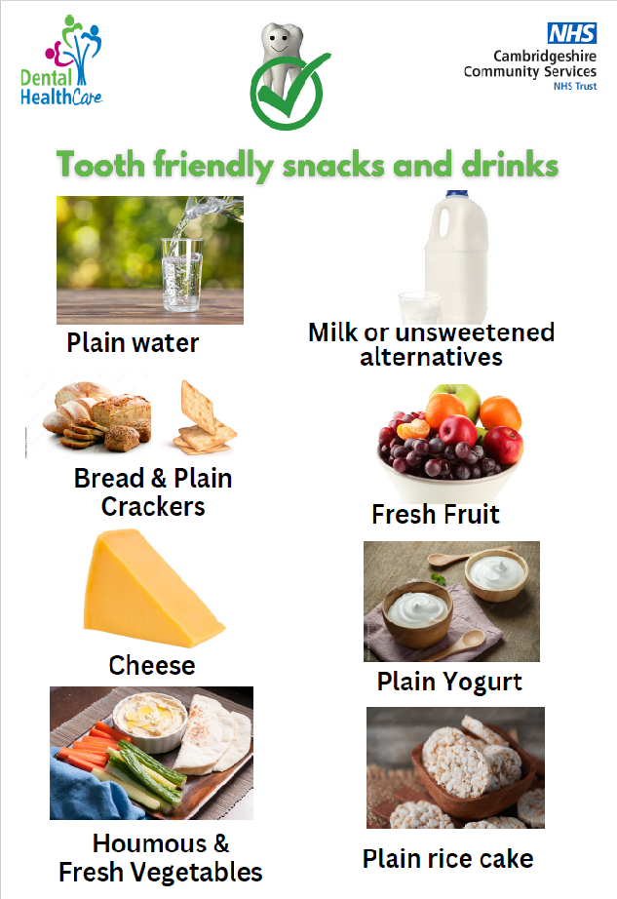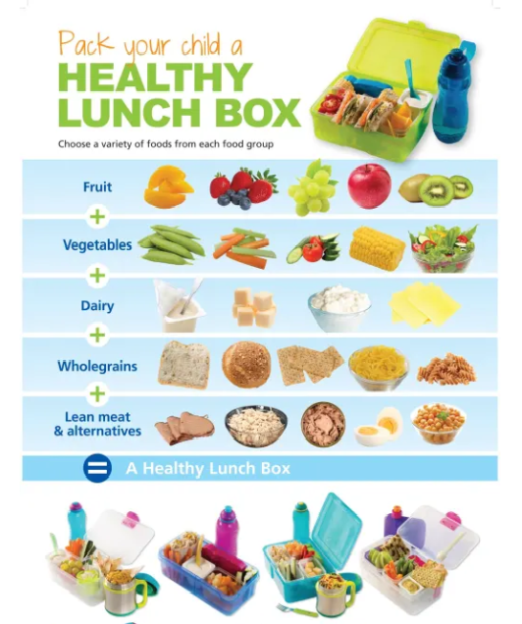
Oral Health and Celebrations.
As a setting we recognise that a birthday or celebration is a very special time for young children and we want to ensure that the occasion is celebrated and enjoyed in a tooth friendly way.
We do this by singing ‘Happy Birthday’, displaying photos of their day on Tapestry, having a Birthday carpet time where they blow out candles on our pretend cake, where a party hat and receive a balloon and birthday card. We ask parents to not bring any cake or sweet treats to celebrate birthdays and encourage healthy tooth friendly options such as fruits, stickers or stationary items. If any cake or sweet treats are brought in to be shared we will send them home with the children and parents can decide to choose to give their child the treat. We encourage this to be part of a meal.
For celebrations where we may provide food such as Christmas, Pancake Day, Easter and Eid we will ensure food and drinks are tooth friendly, for example, water, milk, fresh fruits and savoury items. On occasions such as picnics, fun days and fundraisers we offer a range of tooth friendly foods and drinks.
Local Dentists.
As a setting we promote regular 6-month visits to the Dentist and often arrange for Dentists to come into Pre-School to promote good oral health and the importance of regular check ups. We encourage families to visit their local dental surgeries. Listed below are some local dentists.
- Cobbins Brook Dental surgery, Waltham Abbey, EN9
- Harlow Dental Practice, Chadwick House, Harlow CM20 1EP
- Together Dental Practice, Broxbourne, EN10 7HY
If the child needs urgent dental care, and their dentist does not offer emergency appointments, parents and carers can contact NHS 111.
Legal framework
- EYFS Statutory Framework – Department for Education
Further guidance
The Department of Education guidance on Oral Health https://help-for-early-years-providers.education.gov.uk/health-and-wellbeing/oral-health?fbclid=IwQ0xDSwLGcCNleHRuA2FlbQIxMQABHrSmsN5N-rxDE5TE1SUHc4UCy_OiC2IlrRGXF_X-tBqck1eYRyzaH86fHAkb_aem_QY_AEz4gdk_qZRb0KGcB8g
My Smile Oral Health Supervised Toothbrushing Guidance https://www.dentalhealthcareeoe.nhs.uk/wp-content/uploads/2023/11/supervised-toothbrushing-guidelines-final-20.9.pdf
The British Society of Paediatric Dentistry have created a series of oral health videos for children, in partnership with Dr Ranj, Hey Duggee and CBeebies.
This NHS video on baby bottles and cups explains when to move babies from bottles to cups and why.
The looking after your baby’s teeth NHS page explains how to brush and care for babies’ and young children’s teeth.
This BBC article explains key strategies for showing a toddler how to brush their teeth.
This healthy teeth video from HENRY looks at what we can do to help children grow up with healthy teeth.
The British Society of Paediatric Dentistry provides information to share with parents in a number of different languages.

This policy was adopted by | NAZEING PRE-SCHOOL
On | June 2025
Date to be reviewed | June 2026
Signed on behalf of the provider | Nicky Mainwaring
Name of signatory | Emma Hughes
Role of signatory (e.g. chair, director or owner) | Chairperson


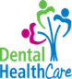

Supervised Toothbrushing Programme
Date

Dear Parent/Guardian,
We are planning to roll out a toothbrushing programme in the setting. We would like to involve your child/children in toothbrushing here once a day, with a fluoride toothpaste. We will have received training to ensure we and the children undertake this safely - the children will be fully supervised by staff when they are brushing their teeth.
You can withdraw your permission at any time from the programme – please inform us to do so.
Please complete and return the below slip as soon as possible.
If you have any questions, please do talk to a member of the staff team.

_________________________________________________________________________
Supervised toothbrushing programme

[I give / do not give] permission for ____________________________________________________ (Child/children’s name/s) to take part in supervised toothbrushing.

Signature: _______________________________________ Date ____________________
I confirm that I have parental responsibility for the above named child/children.

If your child is receiving prescribed fluoride supplements, then please talk to your dentist before allowing your child to participate in the supervised toothbrushing programme.

