68-Ctraining TTEFS APPLICATION FOR TRAINING
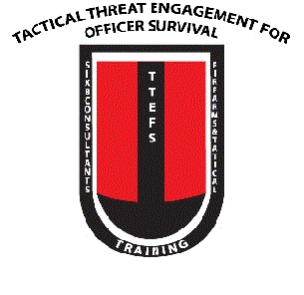

Complete a separate application for each course that you wish to attend. Write in the course title along with the date from the training schedule. Photocopies of this form are acceptable.

COURSE REQUESTED: ____________________________________________
COURSE DATE:______________ _______________ Time:____________
I agree to abide by all safety standards set forth by the TTEFS Instructors and Training Director. I understand that safety during weapons training is of paramount importance during all facets of the training, and that a trainee's instruction may be terminated at any time if his or her safety standards are not deemed satisfactory by the TTEFS staff.
I hereby state that I am NOT a convicted felon, under any Restraining Order or judgment due to Domestic Violence or otherwise forbidden by law to own, possess, or train with firearms, and that I am over the age of 21. I am also NOT UNDER THE INFLUENCE of any control substance or mind-altering drugs while participating in range training operations.
I further agree to sign a waiver releasing TTEFS from any responsibility for injury that may sustain during the training program or during travel to or from the training area.
*Our training and consulting is open to the general public. However, in order to safeguard the material presented and to keep accordance with ITAR&§120.9 the following must be satisfied;
1. Candidates must provide physical verification of citizenship or legal status, such as identification card or legal documentation of legal status.
2. Candidates might have to submit or agree to a background check, a history of criminal activities on your record may prevent you from attending our training and may disqualify you from obtaining a certification of course completion, state license or state permit.
Name (Last) Name (First)________________________
Address__________________________ City__________ State___Zip____________
Phone (Home) Phone (Work)____________
Signature Referred By_________________
Firearms (That you are bringing to the course)
Pistol Shotgun Rifle__________________
Payable to Venmo SIX8CONSULTANTS TTEFS

