Motorcycle ride fundraiser nets $31,560 for families of fallen Kansas City firefighters
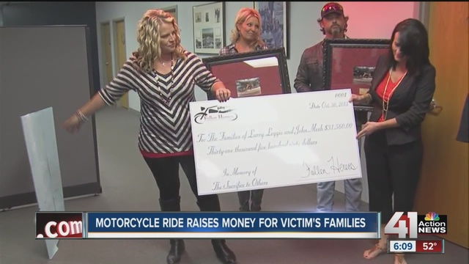

Oct 30, 2015, 8:16PM
KANSAS CITY, Mo. - More than 1,000 people participated in a motorcycle ride benefiting relatives of Kansas City Firefighters, John Mesh and Larry Leggio who lost their lives earlier this month battling a building fire.
A check for $31,560 was presented to the International Association of Firefighters local 42 in Kansas City, Mo.
Ride organizer, Pamyla Fredrick is pleased with the turnout and the money raise to help the firefighters' families.
"We are so grateful to all the volunteers and riders and people who donated and made this possible," explained Fredrick.
"This is not the end, we plan to make the ride an annual event to help the firefighters' families," Fredrick added.
- The group organized the ride in six days
- 1,000 people participated and
- There were 600 motorcycles involved
- The ride was called, Riding for our Fallen Heroes
The riders rode from Lee's Summit and passed in front of fire stations 23, 24, 10 and 17 and rode around the site of the fire at Independence and Prospect in Kansas City, Mo.
The group also sold t-shirts and is pre-selling patches that are still in production.

