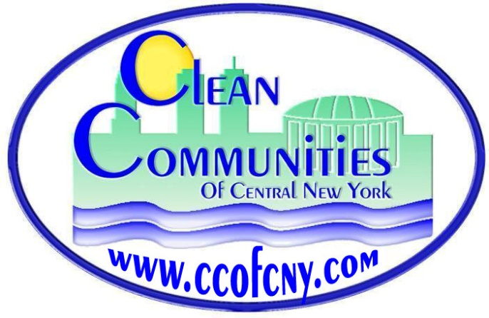
Clean Communities of Central New York
727 E. Washington St. Syracuse, NY 13244
Phone: (315) 278-2061; www.ccofcny.com
Email: Coordinator@ccofcny.com
Executive Director: Barry P. Carr

Memorandum of Understanding (MOU)
Clean Communities of Central New York
Based in Syracuse University’s Center of Excellence, Clean Communities of CNY is a non-profit arm of the US Department of Energy. Our mission is to provide education, outreach, and promotion of advanced transportation technologies along with the use of alternative fuels including: Electricity, Ethanol, Propane, Renewable Propane, Natural Gas, Renewable Natural Gas, Biodiesel, and Renewable Diesel. The use of alternative fuels in transportation is a proven method to reduce emissions of carbon dioxide and particulate matter that causes respiratory stress and is a known carcinogenic. Alternative fuels, especially those created from local waste streams should be used whenever possible to create jobs, reduce landfill waste, and reduce the formation of greenhouse gases.
Clean Communities of CNY works with public and private partners to fund and manage alternative fuel infrastructure development; and we are seeking your support by asking you to participate in our mission.

By signing this MOU, you are agreeing to support our efforts by participating in our educational meetings and events. We will not share your contact information with others; and look forward to meeting you at future events.

Click or tap here to enter text.
Organization Name
Click or tap here to enter text.
Organization Address
Click or tap here to enter text.
City, State, Zip Code
Click or tap here to enter text. Click or tap here to enter text.
Phone Web address
Click or tap here to enter text.
Email

Click or tap here to enter text.
Signature of Organization Representative Date
Click or tap here to enter text. Click or tap here to enter text.
Name (PRINTED) Date

Stakeholder/Member Responsibilities
Please check any of the commitments you wish to make on behalf of your organization/business to support Clean Communities of CNY.

☐ My organization/business commits to incorporating the use of alternative fuels in our fleet to the extent feasible.

☐ My organization/business commits to supporting the development of refueling, service and/or maintenance facilities for alternative fuel vehicles in the Clean Communities of CNY Coalition’s region.

☐ My organization/business will assist the Clean Communities of CNY Coalition in achieving its goals of promoting alternative fuels and reducing emissions by supporting legislation encouraging the use of alternative fuels, advanced technology vehicles and other fuel efficiency strategies.

☐ My organization/business will assist the Clean Communities of CNY Coalition with increasing public awareness of the energy security and air quality benefits of alternative fuels, advanced technology vehicles and other fuel efficiency strategies.

☐ My organization/business will assist the Clean Communities of CNY Coalition by providing in-kind services, to the extent feasible.

☐ My organization/business commits to implementing idle-reduction measures and technologies to the extent feasible, to promote efficient fuel use and decrease emissions.

Please email completed form to info@ccofcny.com.

Information on the U.S. Department of Energy’s Clean Cities Program can be found at: www.cleancities.energy.gov
More information about the Clean Communities of CNY Coalition Program Plan can be found at:
www.ccofcny.com
Coalition newsletters can be found at: www.ccofcny.com/news

