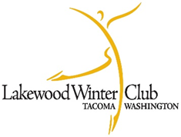
Lakewood Winter Club Board Meeting Agenda
May 10, 2026 (2:00pm)

- Call to Order
- Approval of April 2026 meeting minutes (Directors) – James motions, all approve
- Approval of May 2026 Meeting Agenda (Directors) – Jennifer motions, all approve
- Current Business
  - Next meeting: June
  - Mayblades
    - 420 skaters registered
  - Awards Banquet May 31, 1pm, at Tacoma Golf and Country Club
  - Email for new amendment to be emailed out for Aspire membership. $100 membership, but will still require an adult membership.
  - Governing Counsel meeting: delegates to represent LWC in Colorado
    - Linda Chihara and Jennifer Rubin
- Reports
  - Professionals Report- Director Heidi Sullivan
    - Skate-a-5K in June, used as a fund raiser for LWC, Heidi will work with club on how that will look
    - June 22 summer kick-off
    - July 11, 50th year celebration
      - Club to sponsor light refreshments
  - Test Chairs- Kandace Nance and Michelle Johnson
    - Working to get everything live on June 1
  - Membership chair – Deanna Groshong
    - None at this time
  - Merchandise- Jennifer
    - Checking with jacket sizes and embroidering by July
  - Bookkeeper report- Michelle Johnson
    - Totals will be coming
- Questions

