Commemorative Journal – 2025 Scholarship Dinner Dance Gala

***Purchase information for Journal Advertisement:***

**Name: __________________________________________________________________________**

**Company Name: __________________________________________________________________**

**Address: _________________________________________________________________________**

**City: __________________________________ State: ___________________ Zip: ______________**

**Cell: ( ) __________________________________ Work: _________________________________**

**Personal e-mail: ____________________________ Work email: ____________________________**

**\*\*By filling out this Donation Form, you are authorizing R.C.H.L.E.O., Inc. to use your photos and statements for this Event\*\***

***Journal Advertising Rates:***

* **$2,000.00 Table of ten (10): Permitted to set up display table, hand out Company/service**

**paraphernalia, Souvenir Photos by RCHLEO photographer of Company participants,**

**Company intro at the start of the ceremony, plus inclusion of the Company photo and information in**

**RCHLEO website/Facebook “Sponsors” page for six (6) months.**

* **$500.00 Inside Journal front cover: Submission of JPG art/logo of company with personal statement.**
* **$500.00 Outside back cover: Submission of JPG art/logo of company with personal statement.**
* **$450.00 Inside back cover: Submission of JPG art/logo of company with personal statement.**
* **$400.00 Gold Page: Submission of JPG art/logo of company with personal statement.**
* **$350.00 Full Page: Submission of JPG art/logo of company with personal statement.**
* **$300.00 Half (1/2) Page: Submission of JPG art/logo of company with personal statement.**
* **$250.00 Quarter (1/4) Page: Submission of JPG art/logo of company with personal statement.**

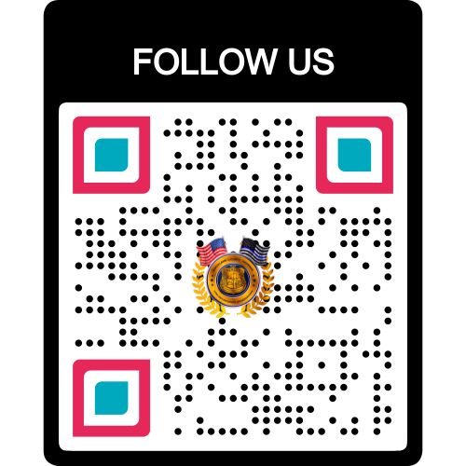

* **$100.00 Business Card Submission of Personal Business Card only.**
* **$______ Donation: I wish to Donate this Amount.**

***\*\*The RCHLEO, Inc. is a proud IRS 501 (c) (3) Nonprofit Charitable Organization and with***

***IRS Tax Deductible Amounts of $250 and above (upon request) gets an IRS approved letter of donation \*\****

***Advertisement Photo-Jpg and Exact Message to be placed in select purchased Journal space (or attach paper Statement)***

**Statement Line 1: ________________________________________________________________________________**

**Statement Line 2: ________________________________________________________________________________**

**Statement Line 3: ________________________________________________________________________________**

**Statement Line 4: ________________________________________________________________________________**

**Statement Line 5: ________________________________________________________________________________**

1. **Advertisement submission/payment “DEADLINE” is:  *October 11, 2025***
2. **Preferred method of payment: *“ZELLE”* via your preferred bank to: “**[**rchleo2020@gmail.com**](mailto:rchleo2020@gmail.com)**”**
3. **By check payable to: *R.C.H.L.E.O., Inc.,* Mailed to: *PO Box 213, New City, NY 10956***
4. **Questions or problems, please get in touch with the following:**

**President: Jorge L. Folch, 845-659-7338 -or- Vice President: Eric Vazquez, 845-323-0490 -or- Treasurer: Iris Lopez, 845-548-0096**