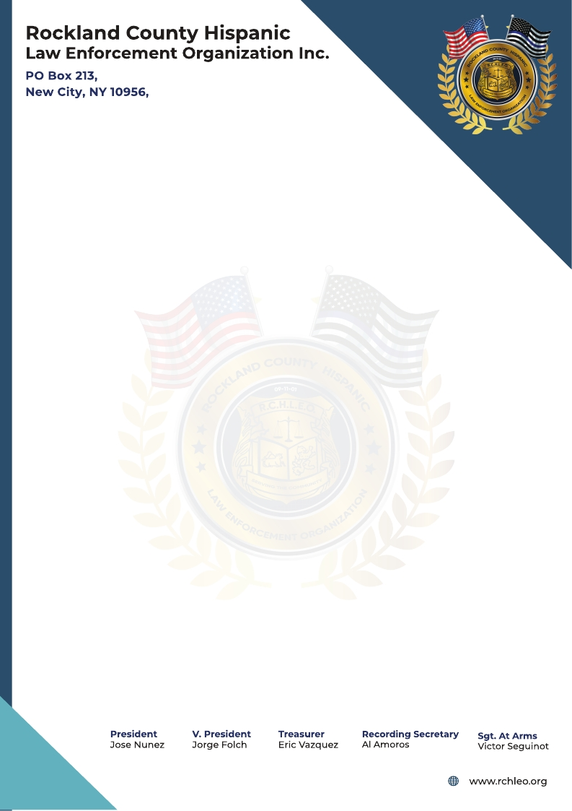

Rchleo2020@gmail.com

Dear Community Friends:

You’re invited to join the Rockland County Hispanic Law Enforcement Organization’s (RCHLEO) annual Scholarship Fundraising Gala!  This event will be filled with raffles, dinner, dancing and live music by the “Los 9 De Sabor” Band.  It is a great opportunity to meet others who support our mission to raise funds for scholarships.

Location: Town & Country Caterers, 922 Route 9W, Congers, NY

Date: October 25, 2025

Time: 7:00 PM- 12:00 AM

At the Gala, RCHLEO will recognize and honor Congressman Mike Lawler, Rockland County Sheriff Captain Omar Munoz, Sheriff Deputy Jose Nunez and Retired NYPD Sergeant Edward Brignoni

for their outstanding contributions to the community.

Thanks to you and your support, this year we were able to award $15,000 in scholarships to five high school graduates.

We once again ask for your support by purchasing tickets or a Journal ad (please see attached journal price flyer). Remember that your gift is a tax-deductible donation since we are an IRS 501 (c)(3) charitable nonprofit organization.

Sincerely,

Jorge L. Folch

(845) 659-7338

RCHLEO President

(On behalf of the RCHLEO Executive Board)

**President Vice. President Secretary Treasurer Sgt-At-Arms**

Jorge L. Folch Eric Vazquez Betsy L. Gonzalez Iris C. Lopez Austin Salcedo