**MZIFP® AIR PURIFICATION AND STERILIZATION TECHNOLOGY**

-

A NEW GENERATION AIR PURIFICATION TECHNOLOGY

MZIFP® stands for Medical Zone-Intensive Field Precipitator. It is highly efficient at removing airborne particles like PM2.5, fungus, dust, pollen, soot, smoke and powerfully deactivates viruses and bacteria.

MZIFP® technology is an innovative upgrade from standard Electrostatic Precipitator technology.

Comparing MZIFP® to standard ESP: MZIFP® has ***10 times the capturing capacity*** of PMs, besides that it solves the problem of unwanted ozone generation, arc and spark.

**THE WORKING PRINCIPLE**

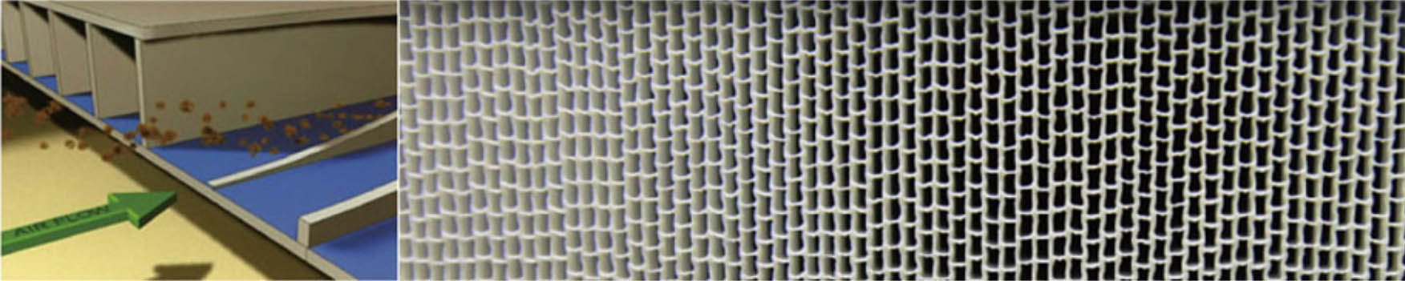

In the MZIFP® system, airborne particles in propelled air flow are electrically charged before passing into honeycomb shaped filter. The filter is formed by layers or rows of tubes which only has 1.8 mm inner spacing and each row contains thin electrode sheets with insulation coating that generate intense electrical fields within the tubes. Charged particles - pollutants, bacteria, germs, viruses - are pulled to the walls of the tubes - and firmly stuck onto the surface.

The polymer tube’s insulation material, prevents current from flowing between electrodes even though with an intense high voltage electric field.

The unique volt-ampere characteristic curve of MZIFP® technology leads to high voltage and extremely low current without the potential dangers of electrode damage and electric shock, which are traditional ESP product weaknesses.

The unique Nano PP-made filter is washable and have no cross infection for the maintenance personnel as all captured living organism are already destroyed and disactivated.

***The filter has a lifespan exceeding 10 years*** with just a small attenuation effect***. The total running cost is much lower and maintenance is much safer than traditional media filters.***

**THE SCHEMATIC DIAGRAM OF MZIFP**

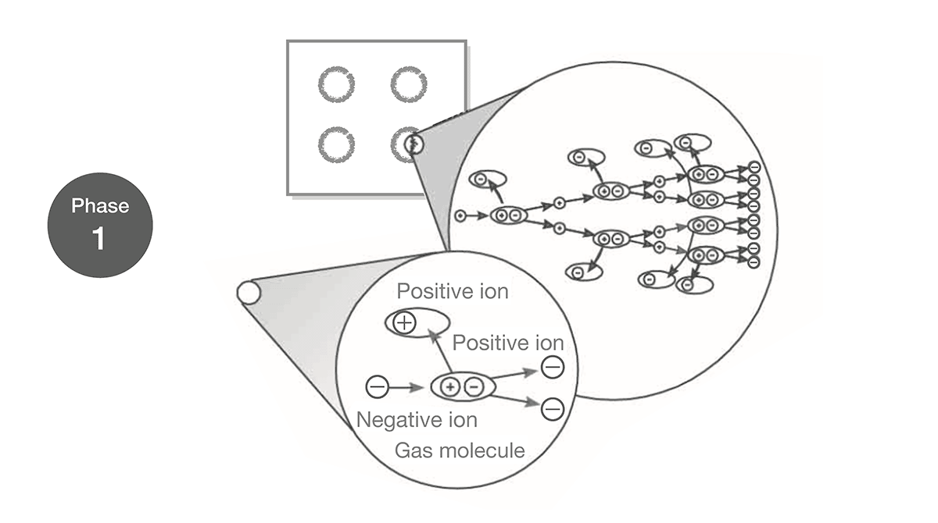

MZIFP® uses a charge grid to generate a corona discharge and release high energy electrons with a voltage of -10.2KV. These electrons form an avalanche effect and generate more and more electrons. Finally, they collide with air molecules to produce lots of negative ions.

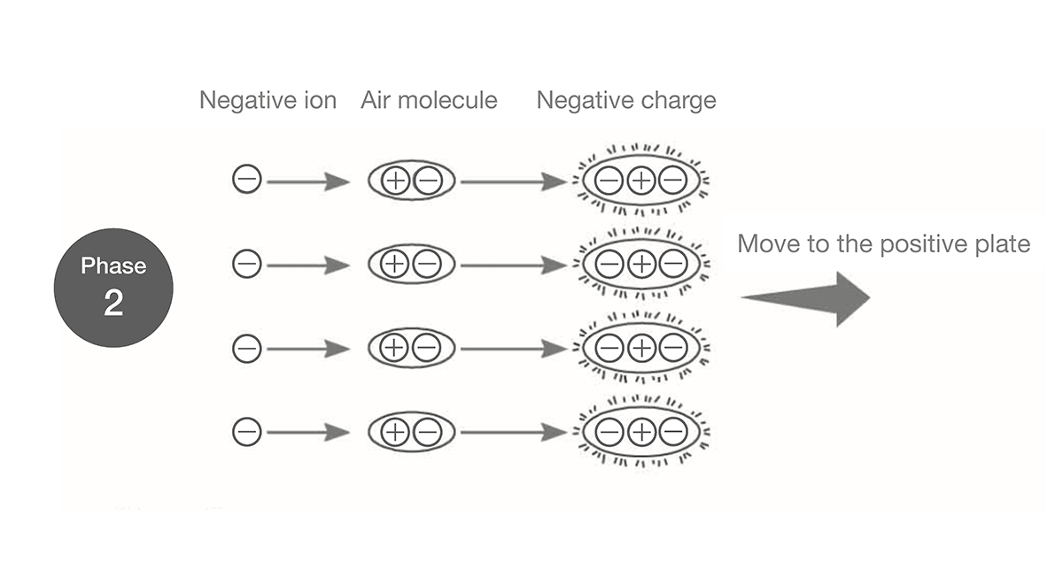

Once away from the corona zone, the negative ions are attracted to the surrounding air, negatively charging the air molecules, which then move towards the MZIFP® positive plate under the action of a strong electric field.

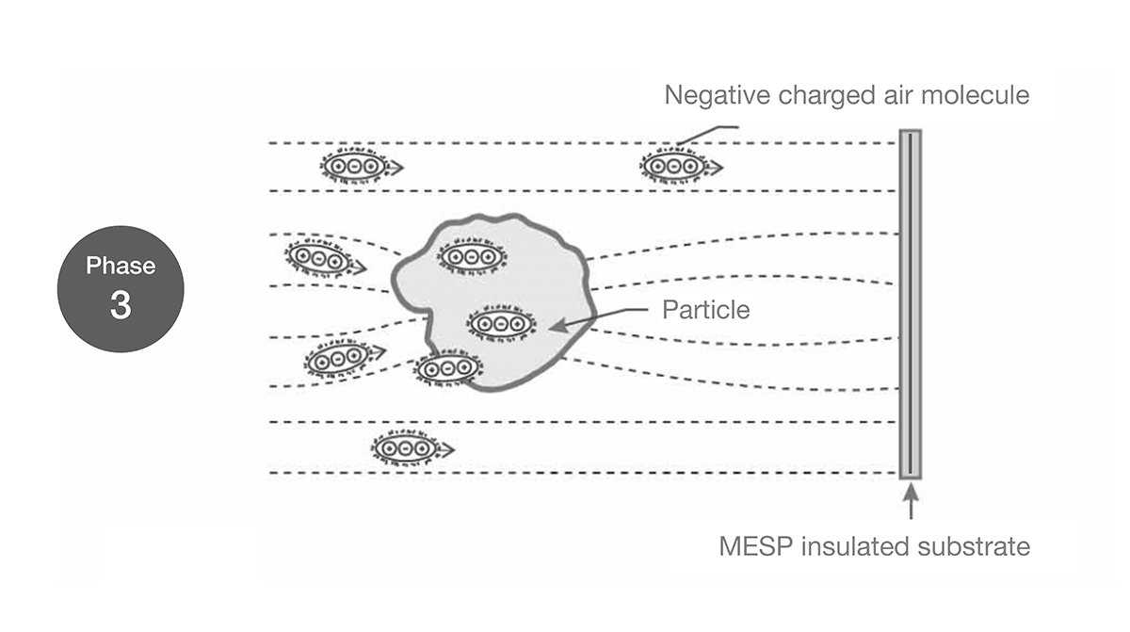

The fine particles will block the negatively charged air molecules from flying and stick them together. The fine particles continue to absorb negatively charged molecules until they are saturated. The fine particles thus carry enough negative charges.

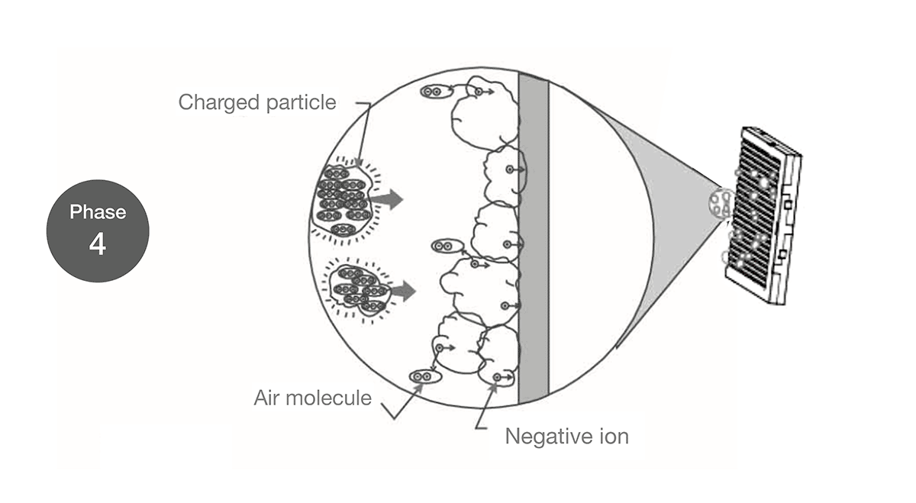

Once the fine particles carry enough negative charges, they move to the positive plate under the action of the dense MZIFP® matrix electric field – and are firmly attracted by it.

**HOW MZIFP® KILL VIRUSES AND BACTERIA?**

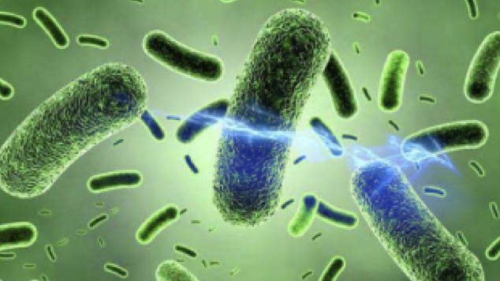

Phase 1. High voltage electrostatic field kills harmful microorganisms

Due to the Intensive Field Precipitator filter’s high-voltage electrostatic effect of up to 10,000 volts, the cell wall of bacteria and protein shell of viruses which pass through will be instantly destroyed by strong coulomb force, thereby disactivating them and instantly killed.

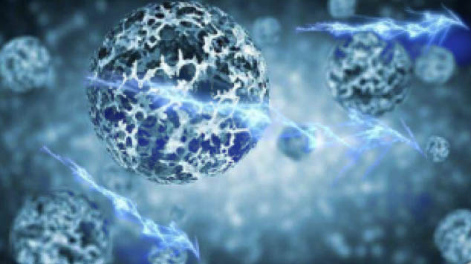

Phase 2. Any virus absorbed on the electrostatic filter will be continuously inactivated

MZIFP can efficiently capture almost all airborne matters even small as 0.01μm in dimension, including biological aerosols with all kinds of viruses and bacteria. In the dust collection module, viruses and bacteria continue to be impacted by high-voltage electric fields, they gradually become carbonized and then inactivated.

SARS-COV-2 AND POTENTIAL AIRBORNE TRANSMISSION

The principal mode by which people are infected with SARS-CoV-2 (the virus that causes COVID-19) is through exposure to respiratory droplets carrying the infectious virus.

Respiratory virus infections are principally transmitted through three modes:  
• Contact transmission  
• Droplet transmission  
• Airborne transmission

Droplet transmission occurs with exposure to larger droplets, smaller droplets, and particles when a person is close to an infected person. Airborne transmission occurs with exposure to smaller droplets and particles at greater distances or over longer times. These transmission modes are not mutually exclusive. For instance, “close contact” refers to transmission that can happen by either contact or droplet transmission while a person is within about 6 feet of an infected person.

**• Able to inactivate viruses and bacteria  
• Able to work along with people  
• Able to keep maintenance costs low**

So, the following measures are our advice during the COVID-19 pandemic:  
• Wear a mask to protect yourself and others and stop the spread of COVID-19.  
• Stay at least 6 feet (about 2 arm’s length) from those who don’t live with you.  
• Avoid crowds. The more people you are in contact with, the more likely you are to be exposed to COVID-19.

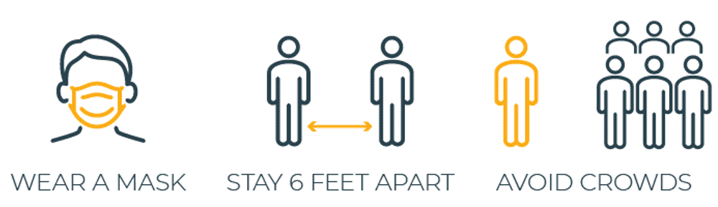

What else?

 We need high-quality air disinfection and purification solutions to protect us from possible airborne transmission. The solution should be:  
**• Able to capture air particulates and aerosol to eliminate hidden place of viruses  
• Able to inactivate viruses and bacteria  
• Able to work along with people  
• Able to keep maintenance costs low**

We recommend using our MZIFP® technology. MZIFP® Air Sterilizing Purifier filter technology could be the best air purifier for COVID and other Viruses & bacteria. It is highly efficient at killing viruses and bacteria and can eliminate airborne particles including PM2.5, pollen, allergen, and other particulate pollutants. The filter is permanently washable. It's safe, without harmful by-products, and can be used in living spaces. **99.99% efficacy of SARS-CoV-2 disinfection** was observed by independent research laboratory namely Innovative Bioanalysis in California, USA

**In 2017***:* ***MZIFP®* comprehensively worked on and promoted the application of *MZIFP®* technology in industrial and civil commercial fields, making significant progress in this area.**

**Alain Al Helaly (Mar. Eng., Building Services & Environmental Engineering)**

**CEO**

**ALBEEA**

**&**

**MZ Environment**