The Lilies of the Midwest

The Lilies of the Midwest (formerly the Daring Fair Maidens) are a trio of Irish traditional musicians in the Madison, WI area. Brought together as a trio for the 2017 Midwest Fleadh, they decided they liked each other’s company enough to meet on a weekly basis and play some tunes. Combining the unique sounds of concertina, mandolin, and fiddle, the Lilies of the Midwest hope to inspire audiences with their infectious energy and joy.
Charlene Adzima
fiddle, voice, feet
As a former step dancer and lifelong musician, Charlene delights audiences with her driving fiddle-playing and terrible puns from the stage.
Kara Rogers
concertina, accordion
A student of original Solas accordionist John Williams, Kara Rogers is an exciting, up-and-coming squeezebox player in her own right. Winner of the 2019 Midwest Fleadh Cheoil on concertina, she has competed in Ireland twice.
Jeanna Schultz
mandolin, bouzouki
Multi-instrumentalist Jeanna Schultz began her mandolin career in college and she hasn't looked back. Her strong rhythmic presence rounds out this dynamic trio.
Rick Nelson
guitar
When available, Ohio-based guitarist Rick Nelson joins LotM as an honorary lily. His thoughtful approach to accompaniment derives from the playing of Micheal O Domhnaill and Daithi Sproule.

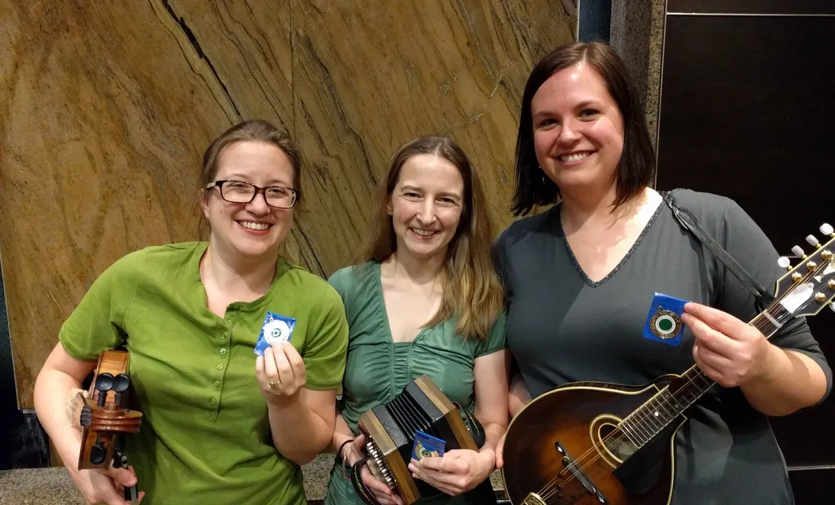
Charlene, Kara, and Jeanna after their 1st place finish in the Over 18 Trio competition at the 2017 Midwest Fleadh Choil (Irish music competition)

Past performances:
Dublin (Ohio) Irish Festival 2018, 2019
Belleville (WI) Music in the Park 2018
Madison Irish Set Dancing
American Players Theatre
Brocach Irish Pub
Fisher King Winery, Verona, WI
Tunes in the Terminal, Dane County Regional Airport, 2019
Dane County Farmers’ Market

Contact:
Charlene Adzima
Cell: 614-507-7071
Charlene.adzima@gmail.com
https://charleneadzima.com/lilies-of-the-midwest

