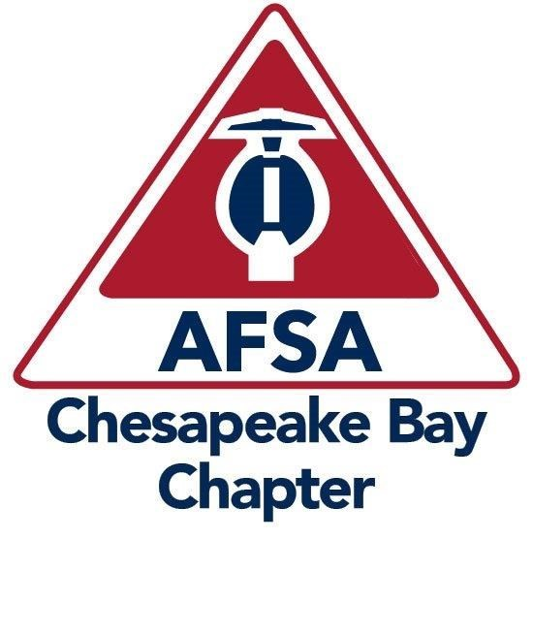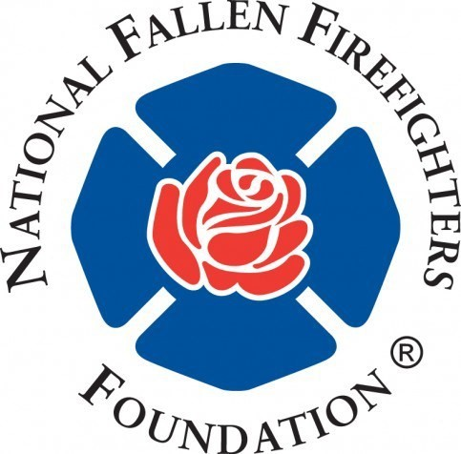
Golf Benefit Tournament!
American Fire Sprinkler Association Chesapeake Bay Chapter
golf tournament in benefit to the
National Fallen Firefighters Foundation
Thursday, September 15th The Links at Challedon
8am - Registration, Coffee & Donuts 6166 Challedon Cir
9am - Shot Gun Start (rain or shine) Mt. Airy, MD 21771
2pm - Lunch, Awards, Prizes & Happy Hour Cash Bar!
Player & Sponsorship Levels
PLATINUM LEVEL  GOLD LEVEL  SILVER LEVEL  BRONZE LEVEL GOLF ONLY |  | $3,000.00 - 8 Players + Hole Sponsor & Recognition  $2,000.00 - 4 Players + Hole Sponsor  $1,000.00 - 2 Players + Hole Sponsor  $500.00 - Hole Sponsor  $250.00 - Single Golfer
** included with the above payment are the range balls, cart, golf game, refreshments & lunch! ** Complete the below & mail or email to Danielle

Company ______________________________________________________
Address _______________________________________________________
City __________________________ State______ Zip Code_______________
Phone ________________ Email ___________________________________

Player 1 Name _________________________
Player 2 Name _________________________
Player 3 Name _________________________ Player 4 Name _________________________

Checks Payable to: AFSA Chesapeake Chapter
Mail to: Danielle Fowler, 2645 Leslie Rd, Mount Airy, MD 21771
Credit Card Payment contact:
Danielle 410-972-1122
email: daniellef@pottersignal.com

