Refillable Cylinder Packages
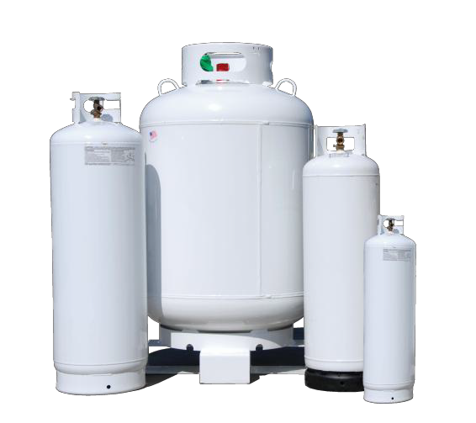
Low pressure cylinder packages developed specifically for refrigerant applications.
Cylinders are refillable and DOT compliant.

DOT Approved (4BA240)
- Liquid Withdrawal Dip Tube
- CGA 510 Diaphragm Valve (Liquid Withdrawal Only)

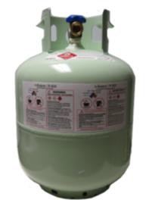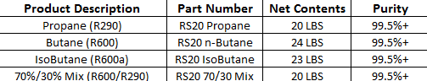

LP 5 Cylinder

LP 239 Cylinder

*Pallet Quantity: 48 Cylinders

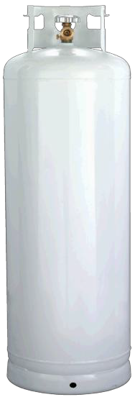

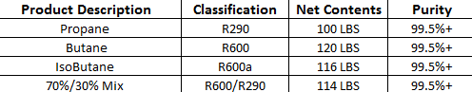

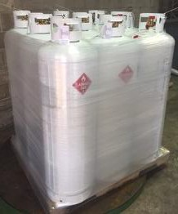
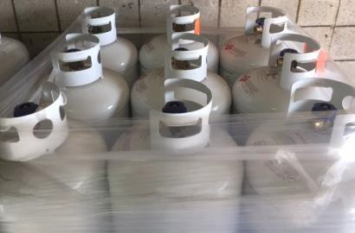
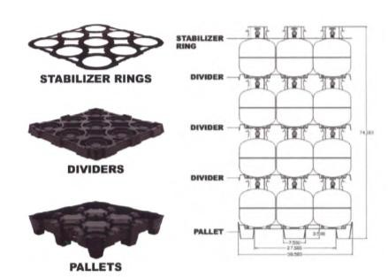
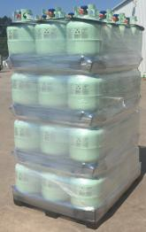
*Pallet Quantity: 9 Cylinders

* Larger Sizes & Bulk Orders Available

