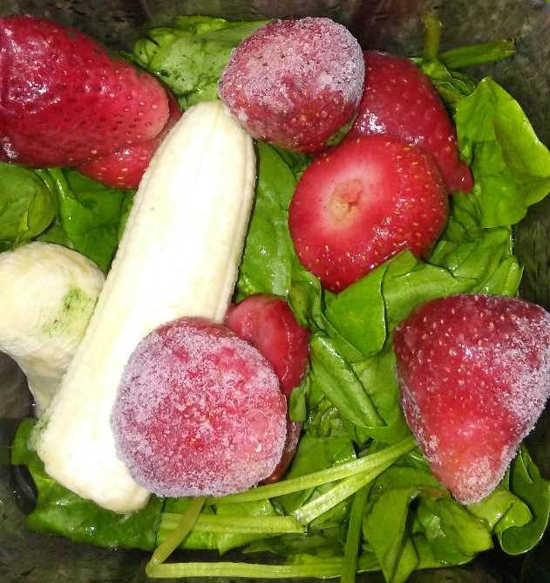
R.E.B.E.L Boxing club

R.E.B.E.L
R.E.B.E.L stands for Rallying, Educating and Building Effective Leadership. For eleven years R.E.B.E.L has been about preventing violence against youth. Young people if given the right resources, community support and opportunities will fight against negative elements and do well for themselves.

Youth & Community
We believe our young people need local access to safe and productive resources. Youth need our skills, support and protection.

Boxing & Healthy Living
Through R.E.B.E.L Boxing Club young people gain self-defense skills, self-pride, self-confidence, discipline, and structure. Young people learn critical-thinking about healthy nutrition and unhealthy foods that make their way into our community and diet.

Head Coach
Wale (wah-lay) is a dedicated activist from Crown Heights, Brooklyn. He has been certified in mentoring, foster care parenting, and educating children through ACS and Dept. of Education. Wale is a vegan nutritionist, kickboxing and boxing champion, two-time collegiate track and field gold medalist, USA Boxing coach and author of “An Introduction to Veganism and Agricultural Globalism”. He is the founder of R.E.B.E.L and co-founder of its parent organization G.A.ME.
Child name: Age: Parent name:
Address:. Apt. City. NY. Zip
Phone:________________________________________ Email:____________________________________________________________
Child sign:___________________________________________ Parent sign: _______________________________________Date___________`
grassrootsgame@gmail.com
718-618-0533

