2026 Calistoga Professional Wine Competition “Judgment of Calistoga”
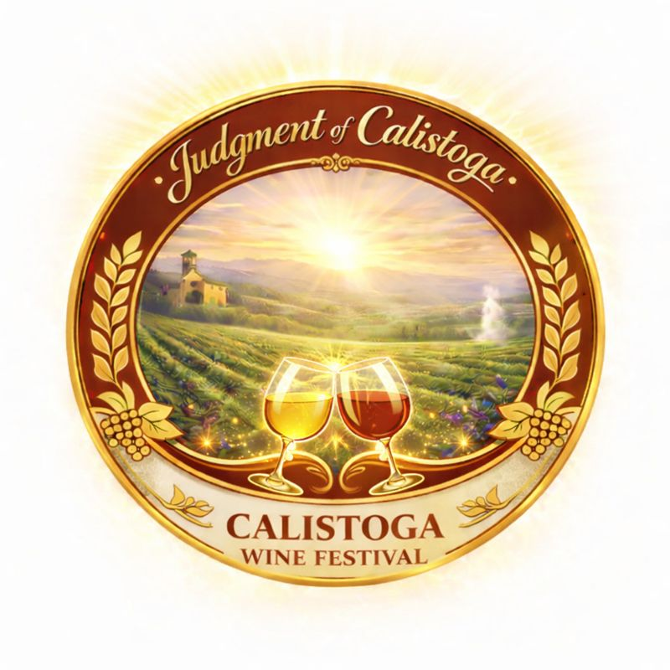

- All bonded (commercial) wineries from the Calistoga AVA are invited to submit their wines for evaluation by professional judges. Please note, only wines made from grapes grown within boundaries of the Calistoga AVA are eligible. Location of the winery (place of production) can be outside the Calistoga AVA but within the Napa Valley AVA. Wines must be labeled for retail sales in the US
- Vintage:
  - Recent Releases: should not be older than 2015: harvest 2015 - 2025
  - Library (aged) wines: commercial release prior to 2015
- All blended wines must have varietal percentage (%) indicated on the Entry form.
- Entries with residual sugar over 0.1% must have residual sugar % stated on the Entry form.
- Wineries Entry fees:
- $40.00 per entry.
- A registration deadline: June 30, 2026.
- How many bottles should I submit? Three (3) 750ml bottles per entry are required.
- Wine varietal categories for submission (Entry): See below
Wine will be collected March-to-June 2026: place of wines delivery will be announced. Deadline June 30, 2026. Refund Policy: Entry fees are non-refundable except in cases of rare wine varietals that do not have enough entries to compete (will be returned and refunded).

Awards
- Granted on a basis of merit and carefully evaluated by expert judges within a peer group of similar products, ensuring a fair and rigorous assessment.
- What awards are given? Wines may receive Double Gold (95+ point score), Gold (90-94-point score), Silver (85–89-point score), or Bronze (75-84-point score) medals. Best in Class honors are also awarded in select categories.
- How will I know if my wine has won an award? Winners are notified via email and published in the local media outlets.
- Who are the judges? Our panel includes sommeliers, wine writers, educators, and other respected industry professionals. All judges are selected for their experience and palate.
- How is the judging conducted? Judging is conducted blind, meaning judges only know the wine’s category, not its brand or producer. Wines are evaluated on their quality, balance, structure, and varietal typicity.
- Not All Wines Medal: Wines that do not meet the judges' standards may receive no medal.
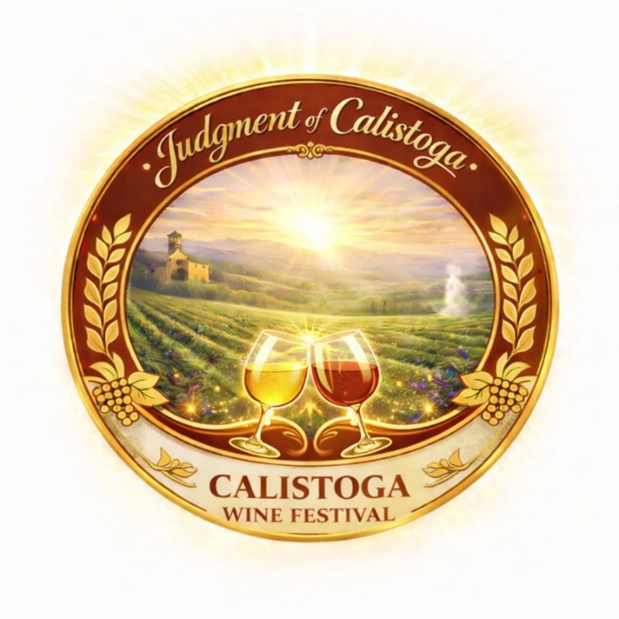

2026 Calistoga Professional Wine Competition “Judgment of Calistoga” Entry Form
White Wines
100 Sauvignon Blanc
105 Chardonnay
110 Semillon
115 Chenin Blanc
120 White blend (indicate % of each varietal)
125 Your white (please, let us know before registering)
Red Wines
200 Cabernet Sauvignon (Cabernet Sauvignon 76-100%)
205 Cabernet/Syrah blend (indicate % of each varietal)
210 Bordeaux blend (indicate % of each varietal)
215 non-Bordeaux blend (indicate % of each varietal)
220 Merlot (Merlot 76-100%)
225 Malbec
230 Cabernet Franc
235 Petit Verdot
240 Carménère
245 Charbono (Bonarda)
250 Zinfandel
255 Petit Sirah (Durif)
260 Syrah (Shiraz)
265 Mourvèdre
270 Grenache
275 Red Rhone blend (indicate % of each varietal)
280 Pinot Noir
285 Your Red (please, let us know before registering)
290 Sweet wine (please, let us know before registering)
295 Rose and Rose blends (indicate % of each varietal)
300 Library Reds (10+ years of aging)

Winery/Company Name:
Owner (proprietor) name:
Winemaker (of submitted wines):
Email:
Address:
Phone:
Signature:

Internal Use only | Class Code | VARIETY (name of product) | Vintage (year) | Designations (proprietary name, vineyard, % of blends, etc.) | Residual sugar  % | Retail price

2026 Wine (submission) Entry Fees
How many Entries:
Price per Entry is $40
Total Entry Fees

Please send the completed last page #4 to email: Tolstunov @yahoo.com

