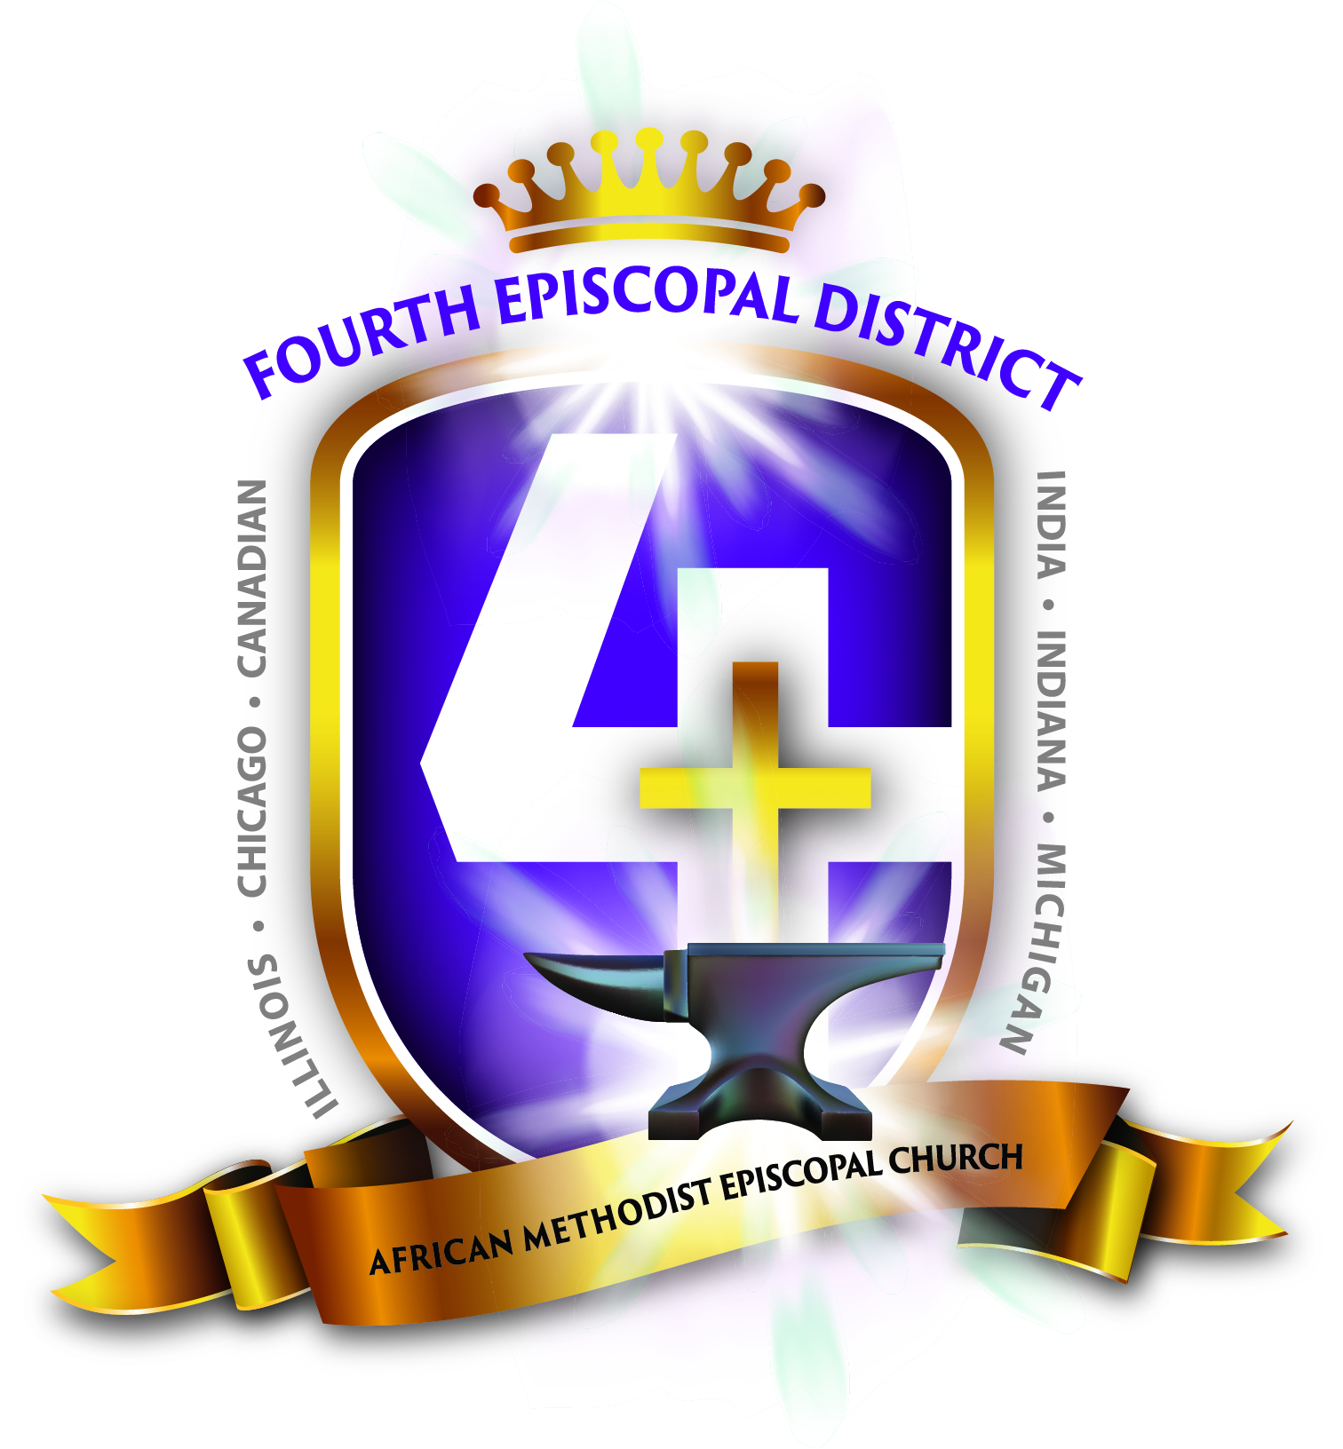
QUARTERLY CONFERENCE STATISTICS

BUSINESS SESSION

Copies to: 1) Bishop 2) Presiding Elder 3) Pastor 4) Secretary

Quarter: (1st) (2nd) (3rd) (4th) (Please indicate one)

Date: _________________________ Church: ______________________

1. Are there any appeals from the members of this society? _______________

2. Are there any applications for licenses to preach or exhort? _______________
If so, who? ______________________, _____________________, _______________________

3. Are there any licenses to be renewed? _______________, If so, who? _______________________
____________________, _______________________, _______________________________

4. How many persons have been converted? _______________

5. How many persons have been received as New Members? _______________
(Joined with Profession of Faith.)

6. How many persons have been received into full membership? _______________
(New Members from the previous quarter)

7. How many persons are now ready to be received into full membership? _______________
(Have completed New Members Class)

8. How many persons have been received by certificate? _______________ (Transfers)

9. How many person (s) have left with a certificate? _______________
(Names_______________, _______________ Where did they go? _______________ )

10. How many persons have left without a certificate? _______________
Name/s of the person/s: _______________ _______________ _______________

11. Total number of persons joining the church this quarter? _______________

12. How many expelled? _______________ Names _______________Why? _______________

13. How many members have died this quarter? _______________
(What are their names? _______________, __________________, ____________________

14. What is the number of full members in this church or on this circuit? _______________

15. How many members of this church or circuit are registered voters? _______________

16. What is the number of New Members in this church or circuit? _______________
(Persons joining from non-Methodist churches and converts.)

17. Have the New Members been instructed in Doctrine, Laws, Discipline, and history of our church during this quarter? _______________

18. What is the number of affiliated members? (Members of our denomination residing in the community who joined temporarily, whose membership is in an AME Church in another locale. These are not to be counted as accessions. _______________ (e.g. Students, Teacher Interns or Armed Services personnel.)

19. What is the number of preparatory members? _______________
(Youth 13 through age 17 not to be counted as full members.)

20. What has been the increase of full members this quarter? _______________
(Those who have completed New Members Class)

21. How many marriages have been performed by the minister this quarter? _______________

22. How many baptisms this quarter?
a) Infants_______________ (few weeks to 5 years old) b) Children (6-12) _______________
c) Youth (13-17) _______________ d) Young Adults (18-39) _______________
Adults _______________

23. How many church schools are there? _______ _ a. Give church school report which should include total number of pupils on roll and average attendance Adults (18 and over)
Youth (12-17) Children (5-11) Cradle Row (under 5)
b. Include amount collected_______________ and amount disbursed_______________
c. Purpose and manner of appropriations _______________ d. Books in library_______________

24. Does this station, circuit, or mission have a WMS organization? _______________ (a). If so, how many members does the WMS organization have? _______________
(If No) Why Not? _______________ Collected Disbursed
25. Does this station, circuit, or mission have a Lay organization? _______________ (a). If so, how many members does the Lay organization have? _______________
(If No) Why Not? _______________ Collected Disbursed
26. Does this station, circuit, or mission have a YPD organization? _______________ (a). If so, how many members does the YPD organization have? _______________
(If No) Why Not? _______________ Collected Disbursed
27. Is the church incorporated separately from the Annual Conference? ____ Where are the incorporation papers located? _____________________ _____________ (Provide the Elder with a Copy)

28. What is the number of (501c3 community projects within the church receiving funds from outside the church? (Child care, Senior Citizens’ Home, Catapult Academy, etc.) _______________

29. Give a report of the Stewards which should include money raised to pay the Pastor/ Minister $__________the presiding elder $__________, benevolence $__________Total Raised $____________ this quarter. (2012 Page 62 Section 2A, No. 2 a, b and d.)

30. Give a report of the Trustees which must include all money handled by the Trustees $_____________ manner and purpose of disbursements Includes all disbursements with the exception of the Pastor’s Salary, Presiding Elder’s Salary, Benevolence and Budgetary items. (2012 Page 65 Section 2 Trustees Letter B 5, A & C

31. Are all church properties insured? _______________What Company_____________________
For what amount? $__________; Is it Current? ___________; If not, why? _______________

32. What is the present indebtedness? Stewards $ _______________ Trustees $_______________
Mortgage on Church/Parsonage, _______________Copier $_______________Van/s $_______________
District $_______________, WMS $______________YPD $____________LAY $__________
LINE OF CREDIT $_____________ 2012 Page 77, Number 6

33. How much money has been collected for General Budget Fund? (Quarterly) $_______________
Retirement and Hospitalization (Annuity bi-annually) $_______________

34. How many subscribers are there this quarter for church periodicals? _______________
Name the periodicals: All the papers

35. Elected District Conference Delegate (Steward) ____________________________________
(s/b done by 1st Quarter)

36. Elected Annual Conference Delegate? (Adult and Young Adult) _____________________________
(s/b done by 2nd Quarter)

________________________________ ______________________________
Pastor Secretary

________________________________________Presiding Elder

