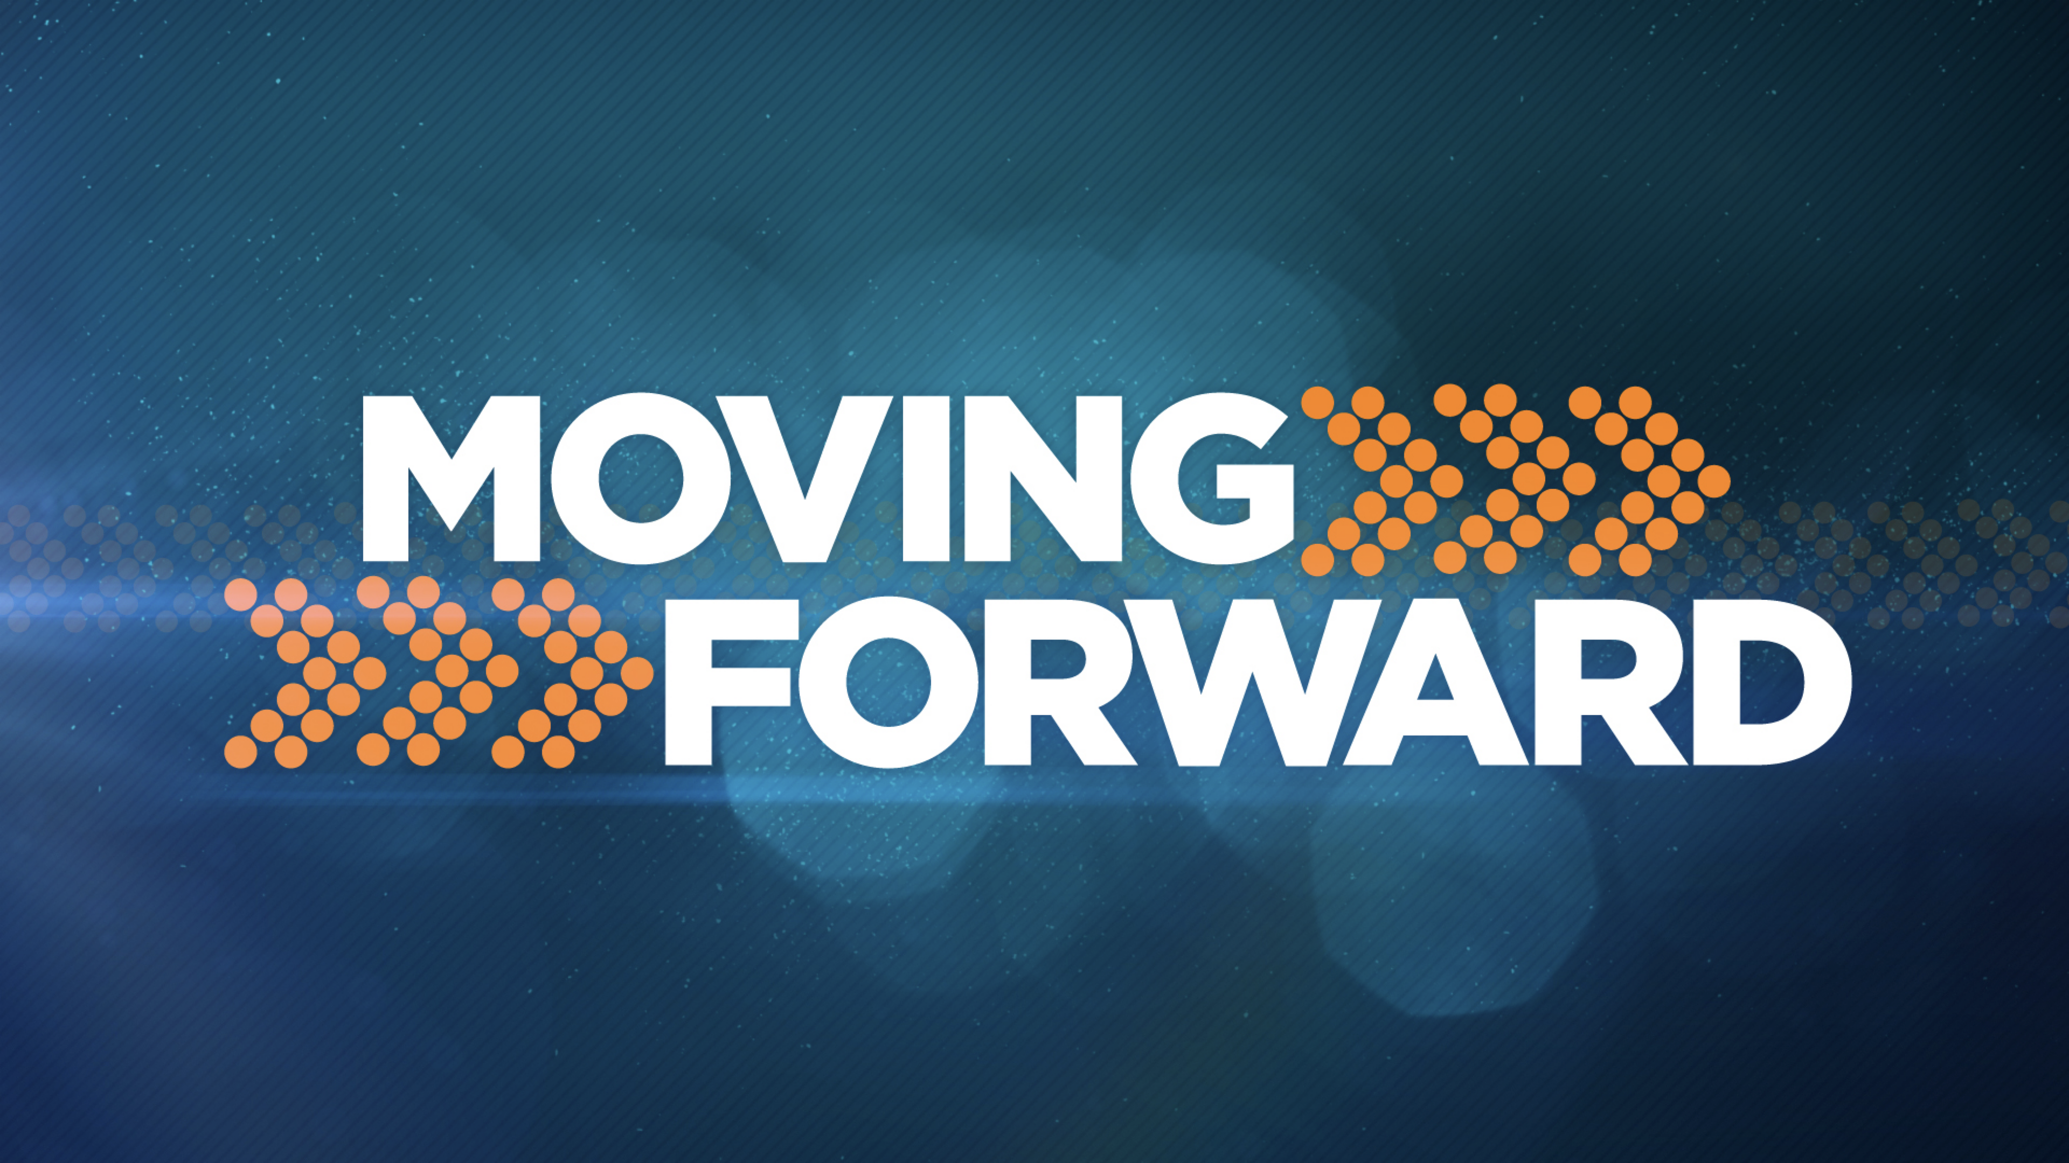
January 16, 2022
Galatians 5:13-23

The call to freedom also means that we are free from _________people.

We are free from seeking the _____________ from people.

The _________________ Sticks of Approval.

We are to live out of the overflow of a ___________ that has been ______ ________ by Christ and to __________ others lovingly.
Am I Connected to God? (Abiding in Him)
Today What’s _______________ My Life?
Pandemics—Expect the __________!
Politics—Not to __________ Anyone!
Political Correctness—Be _______________!
Presence Social Media—Am I ___________!
Am I Listening to the Right Voices?
Take the 30 DAY CHALLENGE and Start your day with God
Jesus is The Better Way! Help When You Feel:
Resentment: I can’t forgive… Philippians 4:13
Fear: I am filled with insecurity… 2 Timothy 1:7
Anxiety: I just can’t relax… 1 Peter 5:7, Philippians 4:6
Discouragement: Ready to give up… Galatians 6:9
Isolation: I am all alone… Hebrews 13:5
Guilt: I am filled with shame… Romans 8:1
Next Sunday’s Message John 15:4, 1 John 3:16-18, Phil. 4:4-9,
Col.3:15-16

