COMMITTEE: Fictional Crisis 1

Committee: Fictional Crisis 1
Topic: The Hunger Games
Chairs: Caroline Schow

Report of the Chairs
Esteemed delegates, we are honored to have the opportunity to moderate this conference. You, the leaders of each of Panem’s 12 districts and the Capital are called here to represent your districts and to discuss the future of the Hunger Games. At this conference, you will all come together, share your views, and make a decision for the people of Panem.

Welcome, welcome districts of Panem! The Hunger Games began more than seventy years ago after a civil war broke out between the districts of Panem. As we all know, the capital won and the war was ended when the Treaty of Treason was signed. Today, the treaty’s main significance now is the creation of the Hunger Games. The Hunger Games are a form of punishment for the districts that rebelled and a reminder to the districts to never rebel again. In some of the first Hunger Games, the mayor of each district picked a tribute themselves. The Hunger Games have evolved and now tributes are picked at random and the Games are televised live.
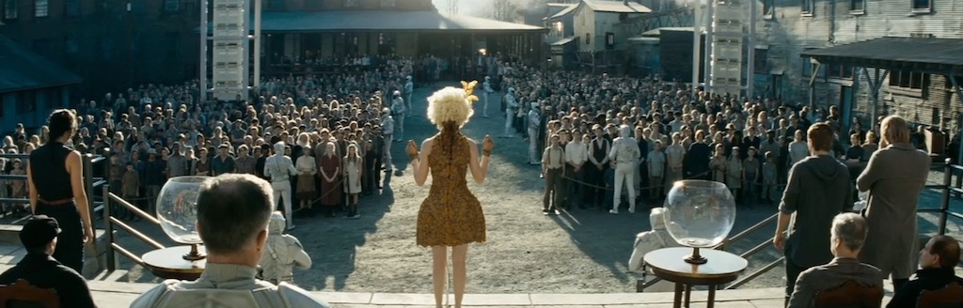
The Hunger Games take place every year when one male and one female from each district are chosen and must fight to the death until one victor remains. The tributes are between the ages of 12 and 18 years old and are chosen at random by an escort sent from the Capitol. This selection is called the reaping ceremony. When the tributes are announced any other reaping-age child from the distinct may volunteer in the tribute’s place. Volunteering is less common in the higher number districts as they see the Games as a death sentence. Lower number districts have a much different view of the Games and see it as an honor to participate and spend their time training while growing up. For this reason, it is much more common for these districts to have tributes that volunteer.
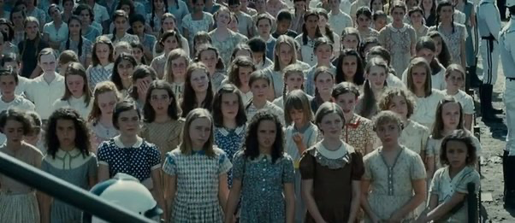
The photo above depicts district children waiting to see who will be selected as their district’s tribute. These children are wearing their most formal attire as the reaping ceremony is a mandatory and important event. Most of these outfits are hand-sewn because the districts are so poor but regardless the district citizens dress as nicely as they can. Their appearance is important because the chosen tributes must make a good impression on the Capitol citizens if they want to find sponsors and support.
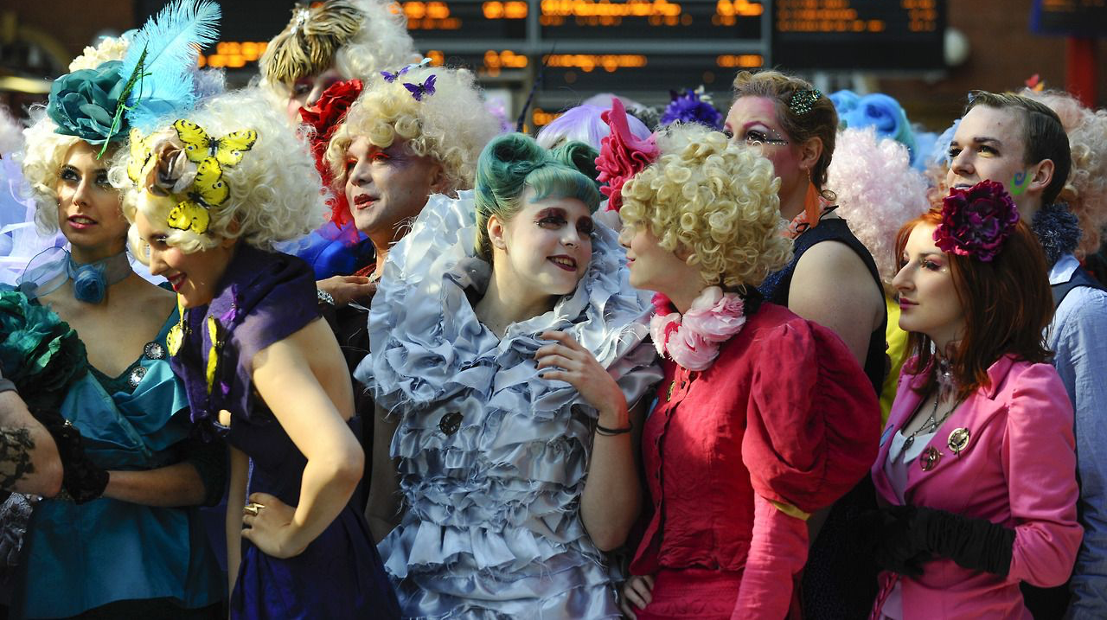
The Capitol citizens pictured above show the extent of their wealth compared to the district citizens. The Capitol views the Hunger Games as entertainment and watches the games live, often making bets on who will win. In the Capitol, the Hunger Games are an exciting event and the tragedy of the Games is not truly acknowledged.
The Peacekeepers are the primary enforcers of order in the districts. They use force to repress political rebels. 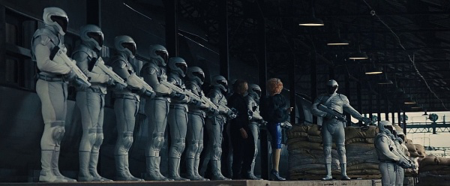
Unfortunately, The peacekeepers have informed us of the rising conflicts relating to the annual Hunger Games. The peacekeepers keep any dissidents and rebels at bay but they can only do so much and they are not able to stop the collective criticism of the Hunger Games. At some point, the people may rise up once more. Now, the time has come for us to decide the future of Panem.
This topic needs to be addressed because the Hunger Games are a reminder to the districts not to revolt against the capitol but if the people’s opinions are ignored a rebellion may be just as likely to occur. Many people in the districts claim that the Hunger Games and reaping ceremonies are a gross form of entertainment and a celebration of violence while others understand that the Hunger Games are a necessity to keep peace in Panem.

Notes and Instructions
This conference will take place before the 74th annual Hunger Games. This means you do not have to take into account any of the events that follow the first movie/ book. You also do not need to draw a focus on the characters in the Hunger Games series (Katniss Everdeen or Peeta Mellark) as those individuals competed in the 74th Hunger Games which has not taken place yet in this conference.
You will be assigned a district (or the Capitol) and you must represent your district's views on the Hunger Games and come to a solution with your fellow delegates. Make sure you fully understand your district’s specific views and opinions on the Hunger Games so you can accurately argue their position. Here are some resources to get started on your research:
https://thehungergames.fandom.com/wiki/The_Hunger_Games_Wiki
https://75thhungergames.weebly.com/all-about-panem.html
Broader Significance
The Hunger Games is an important topic to discuss because it examines a totalitarian government where the citizens are oppressed based on their districts. The scope of this topic expands beyond the fictional concept and can be applied to international issues of corrupt systems of governments, class-based discrimination, suppression of ideas and other freedoms, poverty, starvation, and war.
Delegations:
The Capitol Representative
Representative of District 1
Representative of District 2
Representative of District 3
Representative of District 4
Representative of District 5
Representative of District 6
Representative of District 7
Representative of District 8
Representative of District 9
Representative of District 10
Representative of District 11
Representative of District 12
Representative of District 13
For any questions concerning this topic please contact:
Caroline Schow: schcm-26@rhodes.edu

