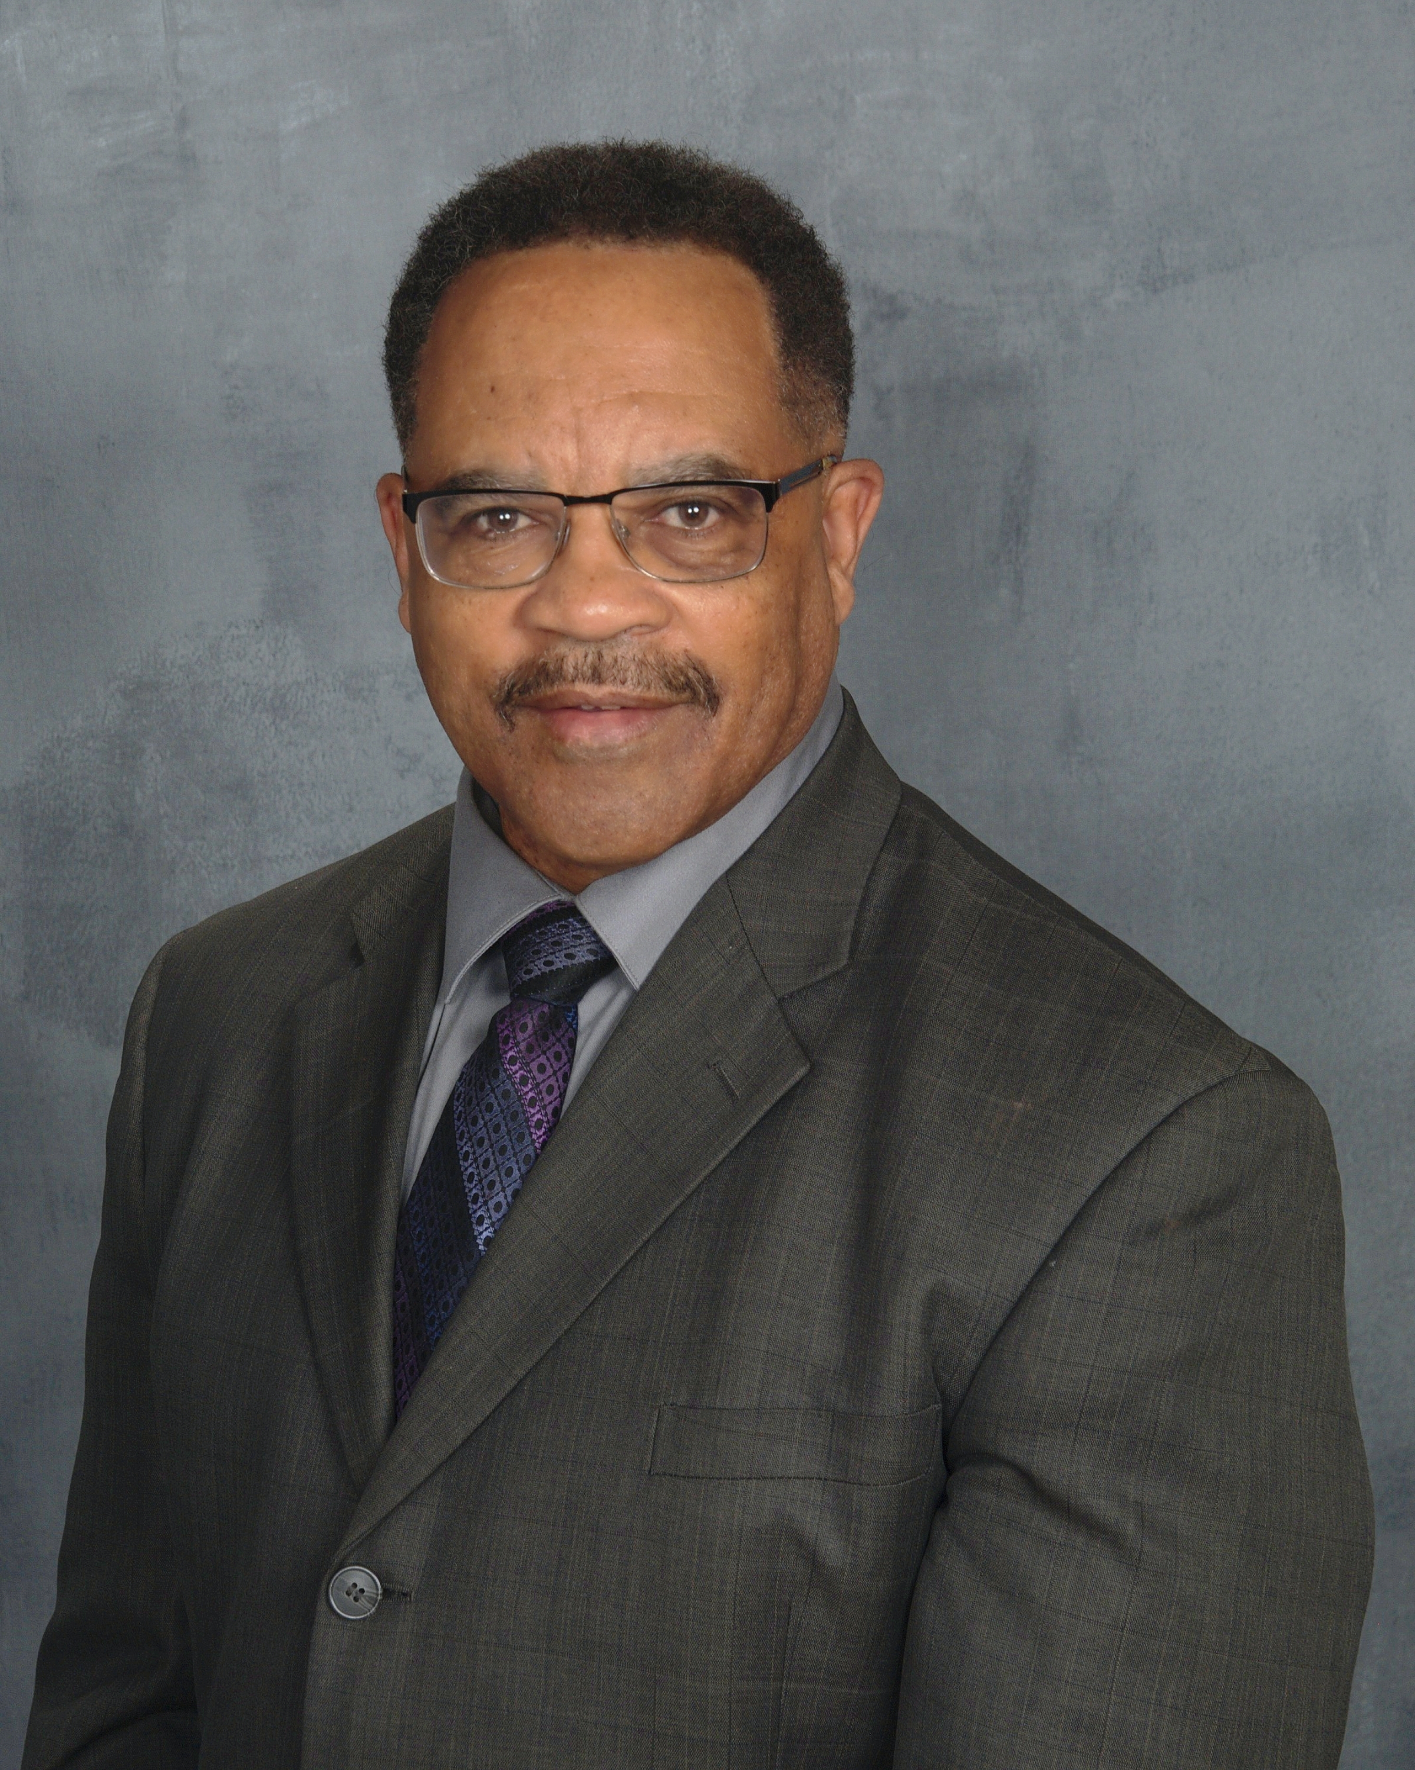
CLYDE RICHARDSON

Clyde was born and raised in Bristol, Connecticut USA. Clyde developed his strong work ethic from his southern father and his strong black self-esteem from his mother who is from Jamaica West Indies. Clyde eventually moved to the metro Atlanta, Georgia area with his wife and two children. It was there that Clyde was introduced to entrepreneurship. His thirst for financial independence motivated him to surround himself with industry leaders who mentored him in business.

Clyde’s career led him to becoming one of the top presenters and trainers and consultants in the direct sales and the referral marketing industry. He has earned numerous credentials and awards of recognition throughout his career. He has been recognized as a top income earner in several companies and has been featured in publications, videos, and on company websites. He has built and maintained organizations of thousands, nationally and in several countries. He has presented trained and motivated thousands of people on stage at numerous events nationally and internationally.

Clyde’s desire to own and operate his own company led him to create and develop several business of his own. Clyde is the founder of Success Team Marketing a company that provides marketing systems for companies and independent representatives in various businesses. Success Team Marketing supports entrepreneurs with opportunities, crypto currency education, business funding and more. Clyde is also the owner of a life and health insurance agency that’s licensed in over twenty states.

When Clyde heard the phrase “most people work hard and spend the money that they make, while wealthy people work smart and spend the money that their money makes them,” it triggered the start of a cause that Clyde has become very passionate about. Most people especially in black and underserved communities have little to no financial education. Each generation continues to pass down the mentality of spending on liabilities that keeps people slaving for money without the knowledge on how to make money work for them. Clyde formed a group called the Passive Income Community. He now spends much of his time and energies in helping people with a PAMM account that has been consistently generating lucrative returns on their money while providing them with complete access to their funds at any time. He is now expanding on helping people internationally in countries and continents like Africa who have large populations of unbanked people with limited finances and resources and are receptive to opportunity.

Clyde enjoys playing and viewing sports and loves to travel. He enjoys reading and writing and is in the process of publishing a book on “investing in one’s-self.” He and his family participate in a volunteer ministry on a regular basis. He strongly believes in maintaining balance in one’s life and in the power and benefits of the diversity of races, nationalities and cultures. Clyde currently sits on several boards and has the ability to bring people together with his experience, vast data base and his credibility. Clyde’s goal is to provide systems that empowering people in business and in life. Clyde always says, “People don’t follow products, people follow people. “ People with vision”. As a visionary, Clyde strives to lead by example in helping people reach their goals and dreams in life.

