**PAN AFRICAN TRADESHOW & INVESTMENT CONFERENCE**

**THURSDAY AUGUST 18TH – SUNDAY AUGUST 21, 2022**

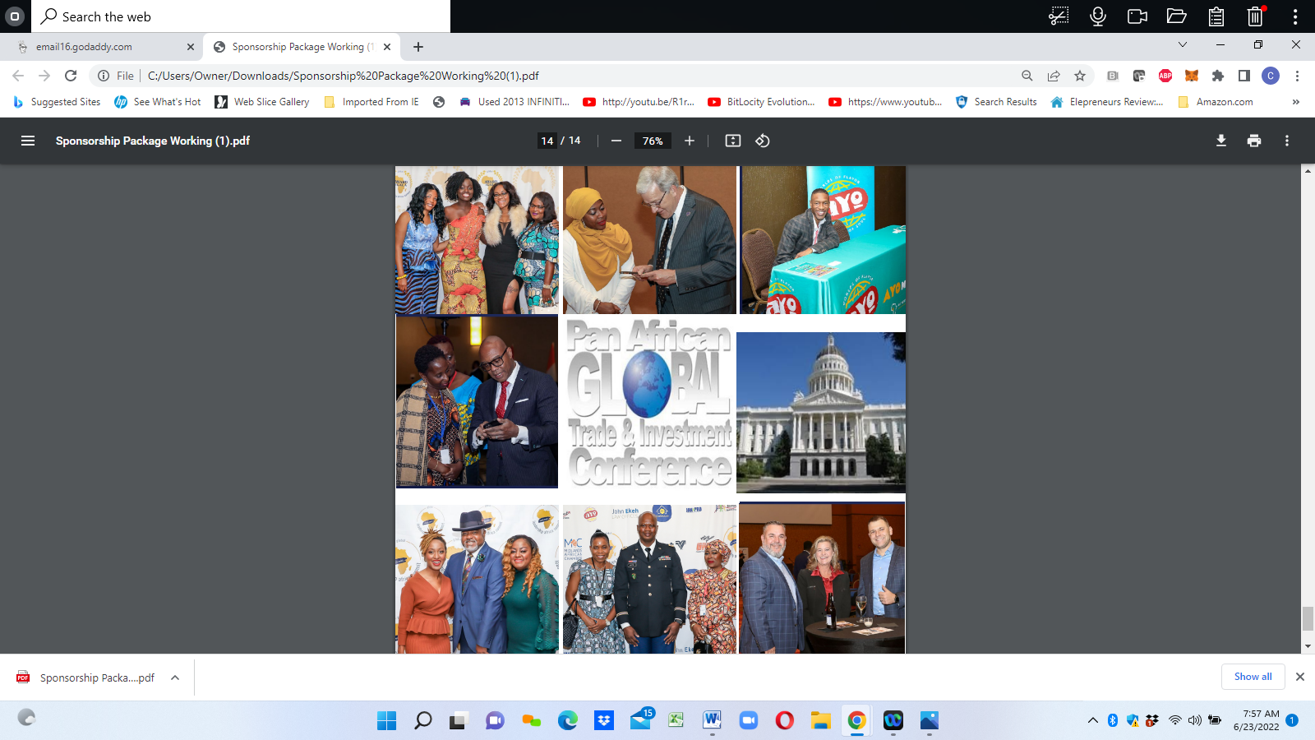

**OPPORTUNITIES TO GROW BUSINESSES AND RELATIONSHIPS BETWEEN AFRICA, THE U.S. AND THE CARIBBEAN**

**DIGNITARIES REPRESENTING:**

**UNITED STATES: Plus Puerto Rico and the US Virgin Islands**

**AFRICA: Cameroon, Ghana, Ethiopia, Kenya, Liberia, Namibia, Sierra Leone, Rwanda, Tanzania, Uganda, Nigeria, Zambia & more**

**CARIBBEAN: Jamaica, Bahamas, Dominican Republic, Haiti and more**

**SUMMERY:**

2022 Pan African Global Trade and Investment Conference aims to gather professional leaders, entrepreneurs, corporate executives, small business owners, and change-makers of diverse backgrounds to celebrate diversity and inclusion at our annual conference in Atlanta, Georgia US

Since 2018, the Summit has attracted more than 1,200 participants from 15 cities to the in person and virtual conference which features live conversations, breakout sessions, and generates rich networking and educational opportunities in professional and personal development.

The 2022 Pan African Global Trade and Investment Conference will focus on establishing and expanding the USA’s trade, commerce and foreign direct invest programs to increase opportunities for robust and sustainable bilateral trade and investment with Africa and the Caribbean.

MORE THAN A CONFERENCE The Pan African Global Trade and Investment Conference focuses on generating increased bilateral investment in economic development where infrastructure and business development would provide needed improvements. This event will create opportunities for marketing US corporate and small businesses products and services in developing African Nations and the Caribbean.

**NOVA TECH FX PASSIVE INCOME PRESENTATION:**

There will be a Nova Tech Financial education & global investment opportunity booth during the entire event.  
There will be a break out room presentation about the importance of financial education, and ways to make the money that people already have work for them to make even more money.

Opportunities to build capital for businesses without having to get in debut or give away equity.

Opportunities to use a global curren do business internationally with a global currency.

**THURSDAY AUGUST 18 – SUNDAY AUGUST 21, 2022**

**MULTIPLE EVENTS, TRADE SHOWS AND BREAK OUT ROOM SEMINARS**

**TO BE HELD AT THESE LOCATIONS:**

**THE NEW BLACK WALL STREET MALL**

**3235 EVANS MILL ROAD**

**STONECREST (ATLANTA) GEORGIA**

**and**

**ALLEN ENTREPRENEUR CENTER**

**8109 MALL PARKWAY**

**STONECREST (ATLANTA) GEORGIA**

**Complete schedule coming soon**