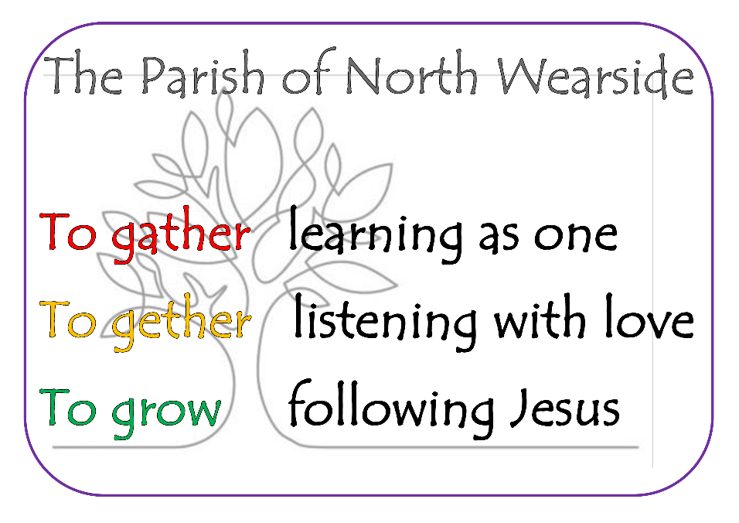

Lockdown liturgy

To use at home if you can’t be at church and whenever you like!

Opening
Clear a space, clear a time. Pause. Breathe deeply. Then begin

‘Bidden or not bidden, God is present’.

As we make time for you in our lives God, come close to us, help us to hear your voice and find your peace.

Collect (Prayer of the week)
27th Sept : Lord of Creation, whose glory is around and within us: Open our eyes to your wonders, that we may serve you with reverence and know your peace at our lives’ end. Through Jesus Christ our Lord. Amen

4th Oct: Almighty God, you have made us for yourself, and our hearts are restless till they find their rest in you: pour your love into our hearts and draw s to yourself, and so bring us at last to your heavenly city where we shall see you face to face; through Jesus Christ your Son our Lord. Amen

11th Oct: God, our judge and saviour, teach us to be open to your truth and to trust in your love, that we may live each day with confidence in the salvation which is given through Jesus Christ or Lord. Amen

18th Oct: Faithful Lord, whose steadfast love never ceases and whose mercies never come to an end: grant us the grace to trust you and to receive the gifts of your love, new every morning, in Jesus Christ our Lord. Amen

(Subsequent weeks in the notices)
Readings
27th Sept: Trinity 16
Exodus 17: 1-7; Philippians 2: 1- 13; Matthew 21: 23 – 32
4th October: Trinity 17
Exodus 20: 1 – 20; Philippians 3: 4 – 14; Matthew 21: 33 – end
11th October: Trinity 18
Exodus 32: 1 – 14; Philippians 4: 1 – 9; Matthew 22: 1-14
18th October: Luke the Evangelist
Isaiah 35: 3 - 6; 2 Timothy: 4: 5 – 17; Luke 10: 1 – 9
(Subsequent weeks in the notices)

Reflection
To be seen in the notices most weeks
Prayers

God of our struggles and of blessing. We pray for those who are sick at this time; in body, mind or spirit…..

We pray for those who grieve, especially …….We remember those whose anniversary falls at this time: (see notices)

We pray for all businesses and organisations as covid-19 restrictions continue to cause anxiety, loss of income and fear for the future.

We pray for the medical profession, key workers and all national leaders and their governments.

We pray for the thing that is especially on your heart today.

We give thanks for …..Name something that you’ve been grateful for this past week.
Pause, enjoy God’s presence.

For these and all our prayers, Lord hear us. Amen

The Lord’s Prayer

⁷ ‘When you are praying, do not heap up empty phrases as the Gentiles do; for they think that they will be heard because of their many words. ⁸ Do not be like them, for your Father knows what you need before you ask him.
⁹ ‘Pray then in this way:
Our Father in heaven,
hallowed be your name.
¹⁰ Your kingdom come.
Your will be done,
on earth as it is in heaven.
¹¹ Give us this day our daily bread.
¹² And forgive us our debts,
as we also have forgiven our debtors.
¹³ And do not bring us to the time of trial,
but rescue us from the evil one. (Matthew 6: 7 – 3)

Blessing
Loving God, stay with us all and bless us, uniting us in the joy and hope of believing. We ask this through God who is Father, Son and Holy Spirit.
Amen

