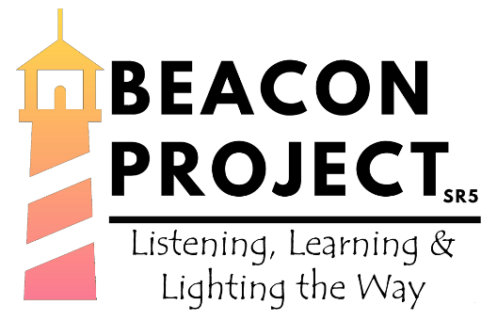

**North Wearside**

**Communities of Hope**

**Project Coordinator**

**Advert**

The Diocese of Durham is engaged in partnership with the National Church (Strategic Development Fund) to invest in low-income communities in ways that bring hope and transformation, both spiritually and physically.

The Beacon Project SR5 is looking for an organised, community-minded person to lead a small team of paid staff and volunteers to establish our Community of Hope in North Wearside.

The Project Coordinator will be responsible for leading and managing the project to meet key targets and outcomes, particularly on the Diocesan priorities around energising growth, challenging poverty, engaging with children and young people and caring for the environment. The post requires confident collaboration both with existing church groups (Diocesan and local) and community partners.

**Planned Project Outcomes**

As a funded project there are agreed outcomes planned over five years. The expectation of ‘fruitfulness’ is that community engagement through the Community of Hope model will result in:

▪ People coming to faith, becoming disciples of Jesus, joining new replicable faith communities;

▪ People discovering a narrative of inspiration and hope, challenging the narrative of decline;

▪ People being a valued part of a strong community network;

▪ People will have a greater sense of wellbeing, engaging in new activities and learning;

▪ People will be better equipped to engage in activities that transform their community;

▪ People will be supported in overcoming life controlling problems.

The Beacon Project SR5 Community of Hope will establish a shop/café that will develop into becoming a sustainable community hub to fulfil the practical, spiritual and social needs of the local people, regardless of their age. The hub will also become a safe place of welcome with coffee, tea and other refreshments, where people can meet to talk, to find help and support, maybe light a candle, to pray, to be still and to explore the Christian faith.

The Beacon Project SR5 is set to grow over the next two years across the North Wearside parish with the aim to deliver sustainable supportive faithful provision for families, young people, and those at risk of isolation in and around our community, bolstered by a series of seasonal activities and events throughout the year. All of this will be underpinned by a thriving network of volunteers. Our vision is clear and we are looking for a Project Coordinator to join us on our journey.

Whilst there is flexibility available, we expect the post is likely to be worked over four days a week, with occasional weekend and evening working.

**Basic Information**

**Hours of work:** 28 hours per week (0.8 FTE) with some flexibility

Will include occasional weekend and evening working.

**Salary:** £20,000 plus pension pro rata (£25,000 FTE)

**Length of contract:** Three years initially, with a view to extend as funding becomes available.

Please contact: Megan Lunn at [megan.lunn@northwearsideparish.com](mailto:megan.lunn@northwearsideparish.com) for an informal discussion about this role.

Closing Date for Applications: 22nd September 2021

Interviews will be held: 5th October 2021

We are an equal opportunities employer with commitment to inclusion.

There is a genuine occupational requirement that the post holders are practicing Christians.