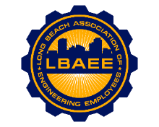

LONG BEACH ASSOCIATION OF ENGINEERING EMPLOYEES
BOARD MEETING AGENDA
Location: Kin Long Beach
December 12th, 2024
12:00-1:00 PM

Call to Order
Henry Corzo, President
Jennifer Williams, Vice President
Chris Sanatar, Treasurer
William Stevenson, Executive Assistant
Tai Vu, Director Group A
Gian Moral, Director Group B
Dillon O’Donohue, Director Group C
Jorge Castillo, Director Group D
Juan Arias, Director Group E
Annie Mosher, Director Group F
Jeffrey Natke, CEA

Approval of Minutes
- Approval of the November 2024 meeting minutes

Adjournment

