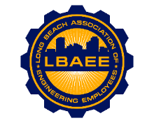
LONG BEACH ASSOCIATION OF ENGINEERING EMPLOYEES
BOARD MEETING AGENDA
Location: Zoom Meeting
April 14th, 2021
12:00-1:15 PM
Call to Order

Approval of Minutes

Welcome & Introduction of New Board Members

Treasurer’s Report

Committee Reports
- Member Relations – TBD
- Grievances – TBD
- Health Insurance Advisory (HIAC) – No Action Needed
- Deferred Compensation Advisory Committee (DCAC) – Zoe
New Business
- Furlough Status – Jeff
- Political Action Committee (PAC) – Zoe
Continuing Business
- PERB Charge Update – Jeff
- Election Update – TBD
- Disability Insurance Deductions – Zoe
- Environment Planning Specialist salary survey – Jorge
- Public mural update – On Hold
- T-shirts – Juan
Round Table

Close Session
Adjournment

