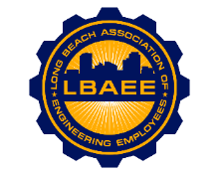

**LONG BEACH ASSOCIATION OF ENGINEERING EMPLOYEES**

**BOARD MEETING AGENDA**

**Location: Zoom Meeting**

**February 10th, 2021**

**12:00-1:00 PM**

**Call to Order**

**Approval of Minutes**

**Treasurer’s Report**

**Web Site Update**

**Committee Reports**

* Member Relations – TBD
* Grievances – TBD
* Health Insurance Advisory (HIAC) – No Action Needed
* Deferred Compensation Advisory Committee (DCAC) – Zoe

**New Business**

* Disability Insurance Deductions – Zoe
* Environment Planning Specialist salary survey – Jorge

**Continuing Business**

* PERB Charge Update – Jeff
* Elections – Jose and Jason
* Public mural update – On Hold
* T-shirts – On Hold

**Round Table**

**Close Session**

* None

**Adjournment**