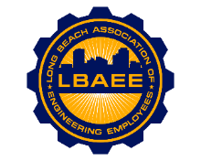
LONG BEACH ASSOCIATION OF ENGINEERING EMPLOYEES
BOARD MEETING AGENDA
Location: Zoom Meeting
January, 21st 2020
12:00-1:00 PM
Call to Order

Approval of Minutes

Guest Presentation
- PAC Presentation George Urch and Sunny Zia
Treasurer’s Report
- CEA Increase
- CEA Bi-annual Payments
- 2021 Budget
- (Anything else to add?)
Web Site Update

Committee Reports
- Member Relations – TBD
- Grievances – TBD
- Health Insurance Advisory (HIAC) –No Action Needed
- Deferred Compensation Advisory Committee (DCAC) – No Action Needed
New Business
- Environmental Specialist revised class spec review
Continuing Business
- PERB Charge Update – Jeff
- Elections – TBD
- Public mural update – On Hold
- T-shirts – On Hold
Round Table

Close Session
- None

Adjournment

