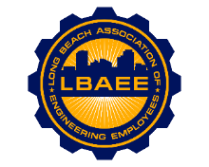

LONG BEACH ASSOCIATION OF ENGINEERING EMPLOYEES
BOARD MEETING AGENDA
Location: Zoom Meeting
July 14th, 2021
12:00-1:15 PM

Call to Order

Approval of Minutes

Treasurer’s Report

Committee Reports
- Member Relations – TBD
- Grievances – TBD
- Health Insurance Advisory (HIAC) – No Action Needed
- Deferred Compensation Advisory Committee (DCAC) – No Action Needed

New Business

- Hybrid Work Program - Zoe
- Ports Repopulation Plan - Zoe

Continuing Business
- Political Action Committee (PAC)
- PERB Charge Update – Jeff
- Election Schedule – Jason
- Environment Planning Specialist salary survey – Jorge
- T-shirts – Juan

Round Table

Close Session

Adjournment

