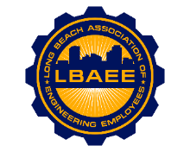
LONG BEACH ASSOCIATION OF ENGINEERING EMPLOYEES
BOARD MEETING AGENDA

The March 2021 Board Meeting is CANCELED.

