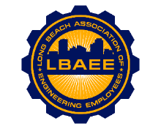
LONG BEACH ASSOCIATION OF ENGINEERING EMPLOYEES
BOARD MEETING AGENDA
Location: Zoom Meeting
May 19th, 2021
12:00-1:15 PM
Call to Order

Approval of Minutes

Welcome & Introduction of New Board Members

Treasurer’s Report
Disability Insurance Deductions-Jose

Committee Reports
- Member Relations – TBD
- Grievances – TBD
- Health Insurance Advisory (HIAC) – No Action Needed
- Deferred Compensation Advisory Committee (DCAC) – No Action Needed

New Business
- Vote to release of Jacob Banfield from the Executive Assistant Board Position
- Assignment of Duties to Directors
- Political Action Committee (PAC) – No Updates
Continuing Business
- PERB Charge Update – Jeff
- Election Schedule – Jason
- Environment Planning Specialist salary survey – Jorge
- Public mural update – Jason
- T-shirts – Juan
Round Table

Close Session
Adjournment

