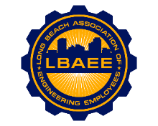

LONG BEACH ASSOCIATION OF ENGINEERING EMPLOYEES
BOARD MEETING AGENDA
Location: Zoom Meeting
September 8, 2021
12:00-1:15 PM

Call to Order

Approval of Minutes

Welcome & Introduction of New Board Members

Treasurer’s Report

Committee Reports
- Member Relations – TBD
- Grievances – TBD
- Health Insurance Advisory (HIAC) – No Action Needed
- Deferred Compensation Advisory Committee (DCAC) – No Action Needed

New Business

- Election Result – President Rodriguez
- Proof of Vaccination for City of Long Beach Employee

Continuing Business
- Political Action Committee (PAC)- TBD
- PERB Charge Update – CEA, Jeff Natke
- Environment Planning Specialist salary survey – Director Castillo
- T-shirts – Director Arias
- Hibrid Work Program – Vice President Schumacher
- Ports Repopulation Plan – Vice President Schumacher

Round Table

Close Session

Adjournment

