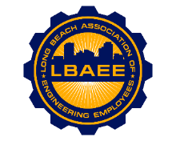

**LONG BEACH ASSOCIATION OF ENGINEERING EMPLOYEES**

**BOARD MEETING AGENDA**

**The December 2022 Board Meeting is CANCELED.**