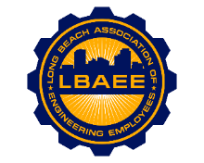

LONG BEACH ASSOCIATION OF ENGINEERING EMPLOYEES
BOARD MEETING AGENDA
Location: ZOOM
November 9, 2022
12:00-1:15 PM

Call to Order
Jason Rodriguez, President
Zoe Schumacher, Vice President
0, Treasurer
Susan Sun-Stephan, Acting Executive Assistance to the Board
Tai Vu, Director Group A
0, Director Group B
Dillon O’Donohue, Director Group C
Jorge Castillo, Director Group D
Juan Arias, Director Group E
Robert Tinsley, Director Group F
Jeffrey Natke, CEA

Approval of Minutes

Treasurer’s Report.
Committee Reports
- Member Relations – Arias
- Grievance status - CEA
- Health Insurance Advisory (HIAC) – Rodriguez
- Deferred Compensation Advisory Committee (DCAC) – Rodriguez

New Business
- LBAEE Vice President appointment- President Rodriguez
- Change LBAEE banking entity- President Rodriguez
- Update on Elections- President Rodriguez
- City’s proposed changes to the EERR- open

Continuing Business

Round Table

Close Session

Adjournment

